GSL Report
Responsible Use of AI

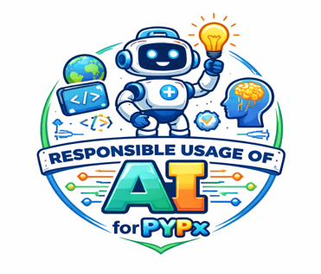
Team Members: Parnika Kalra, Shreyas Singhal, Krish Arora, and Iylahn Die Axel

Team Members and Roles:
- Parnika Kalra – Team Leader & Project Head
- Shreyas Singhal – Technical Lead
- Krish Arora – Research & Development Coordinator
- Iylahn Die Axel – Support & Documentation Manager

We nominated this topic because:
Parnika Kalra: I have been connected to this topic for the past two years and have actively learned and explored different aspects of responsible use of AI.
Shreyas Singhal: The responsible use of AI is very important because it plays a vital role in our lives so by choosing this topic, I decided to help people who were facing difficulty understanding it.
Krish Arora: Responsible use of AI is very important because it is becoming a big part of our daily life so by choosing this topic I wanted to spread awareness about using AI carefully and ethically.
Iylahn Die Axel: AI tools are growing very quickly and many people use them without fully understanding them so by choosing this topic I wanted to learn more about AI and help others use it in a responsible way.
Aim of the team:
Our aim was to encourage people to explore technology and understand its wide range of uses in everyday life. We wanted to provide meaningful exposure by showing how technology can be used not just for entertainment, but also for learning, problem-solving, and innovation. Through this, we hoped to build curiosity, confidence, and awareness among individuals, helping them become more responsible and informed users of technology. Additionally, our goal was to inspire people to use technology creatively and effectively to improve their lives and contribute positively to society.

SDG’s Showcased during this journey:
- SDG 4: Quality Education – Taught AI, cybersecurity, and online safety
- SDG 9: Innovation – Promoted use of modern technology and AI
- SDG 16: Strong Institutions – Spread awareness about ethical and safe AI use
- SDG 10: Reduced Inequalities – Helped NGOs and communities access technology
- SDG 17: Partnerships – Collaborated with experts, NGOs, and speakers

Actions Taken:
Parnika conducted a podcast with Mr. Jagmeet Singh, the AI Platform Lead at NatWest, discussing the role of AI in banking.
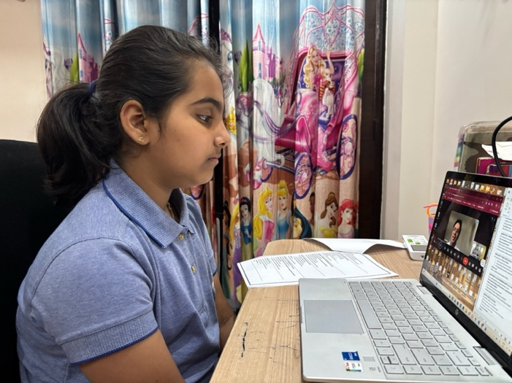
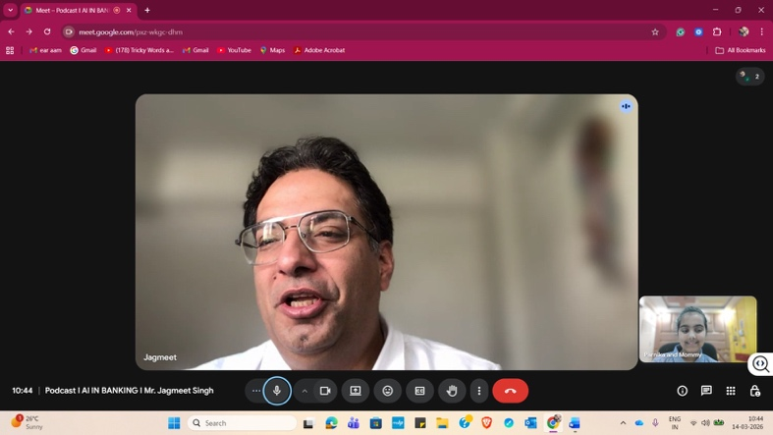

Parnika conducted NGO sessions on academic honesty, online safety, and smart tools for daily use, in collaboration with Anubhav Ek Ehsaas. Where she also received an appreciation letter for teaching more than 50 students and making their lives more easier, faster, and more efficient.

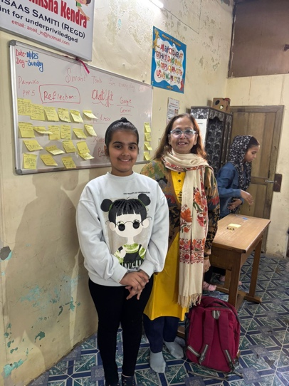
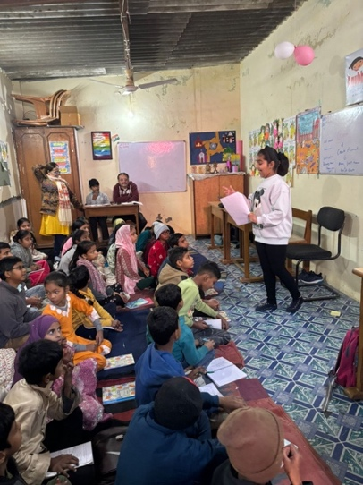

Parnika went on an educational field trip to Manav Rachna University, where she explored modern facilities and learned about innovation and technology.

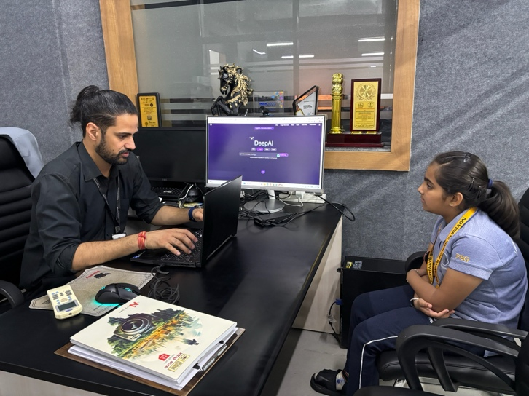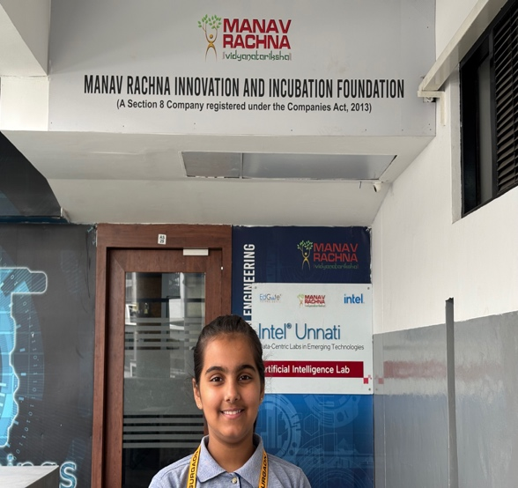

Shreyas conducted a podcast with Mr. Zoravor Gill on AI in banking, covering fraud detection, improved customer service, faster decision-making, and its benefits.
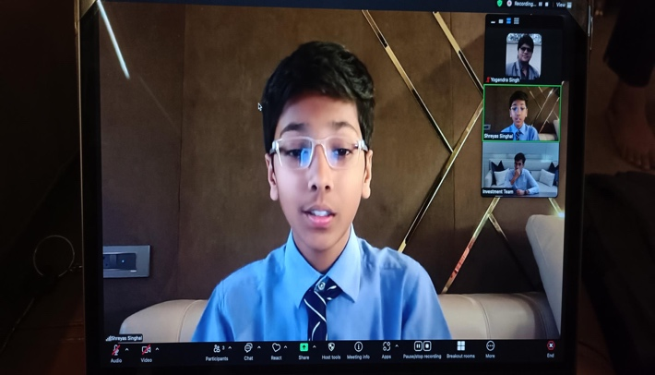
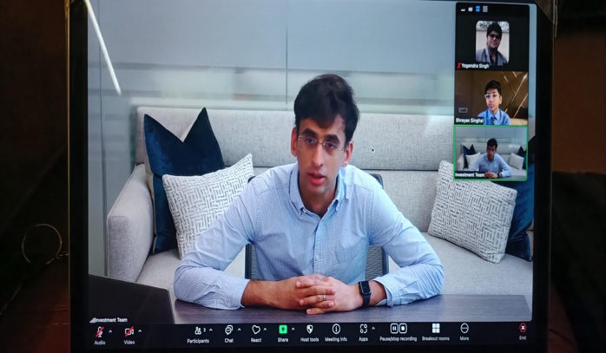

A guest speaker session by Ms. Shinu was conducted, where she shared valuable insights and real-world experiences.
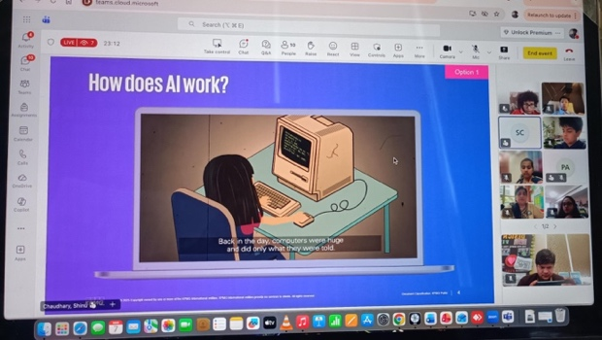
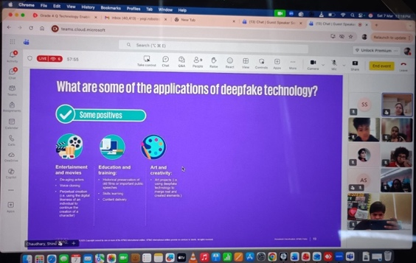

‘
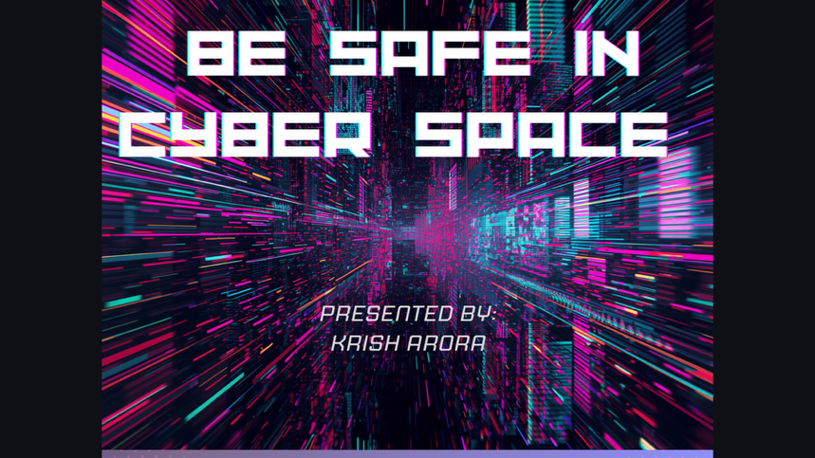
Krish delivered a presentation on cybersecurity to students in Grades 2, 3, and 4, where he explained its importance and key concepts.

Measuring the Impact:
We measured the impact of our actions by seeing how people’s understanding and behaviour changed. During our NGO sessions, we noticed that people became more aware of online safety and the responsible use of AI. Their feedback showed that they could use what they learned in real life. We also looked at how many sessions we conducted, podcasts we created, and people we reached. Overall, the increase in awareness and responsible behaviour showed that our actions made a positive impact.

Learning Profile and ATL skills enhanced:
The learner profile attributes demonstrated were communicators as we engaged with many people and inquirers because we explored different aspects of AI and technology.
The ATL skills that were strengthened included research skills, as we explored and gathered information on various topics, and communication skills, as we interacted with many new people.

Reflection as Lifelong Learners:
Parnika:
I chose this opportunity not randomly, but as a step toward my future career. I have a strong interest in technology and have been actively involved in it. I am deeply inspired by my parents, who are both engineers working in the field of technology. I am also motivated by my mentors, who consistently encourages me to explore technology and use it ethically. Their support inspires me to use technology with purpose.
