Field Report
Visit to Tumshangilieni Mtoto
A Field Visit by the Rusinga School Year 8S GSL Team
Niamh Malenge-Page

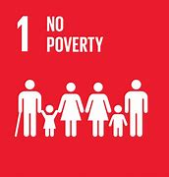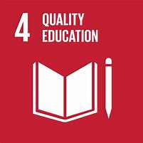
Report on the Visit to Tumshangilieni Mtoto

Introduction

Tumshangilieni Mtoto (Shangilia) is a non-profit organisation founded in 1994 by the late Kenyan actress Anne Wanjugu to rescue, care for and rehabilitate abandoned children. Currently, Shangilia provides 137 children with a home at Kibagare in Nairobi, and supports another 57 children from the local community – the Kibagare and Kangemi Bottomline slums – bringing the total to 194 children. In addition, Shangilia sponsors 62 secondary school students, of which 34 are girls and 28 are boys, who have passed their national exams by 300 marks and above.

Our GSL Team consists of the following students:
- Niamh Malenge-Page (Group Leader)
- Malayka Makanda (Business Ideator)
- Justin Mwandiki Otto (Treasurer)
- Alpha-Sarah Kahara (Event Organiser)

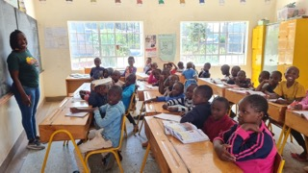 | 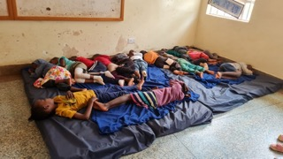 | 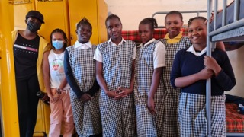
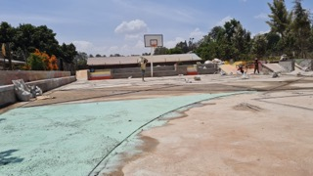 | 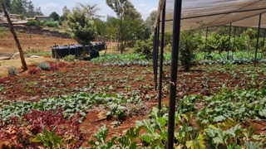 | 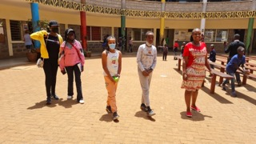

Challenges

Shangilia’s greatest challenges are:
- Child abandonment by their parents (community)
- Demands from the children to trace their parents
- Financial burden of caring for 194 children and dependence on well-wishers
- Traumatic backgrounds of children especially those raised on the streets and those that have suffered traumatic events (alcoholic and abusive parents).

Shangilia receives some funding from the German non-profit organisation, Shangilia Germany, but is required to raise Kes. 4.5 million locally for consumables including:
- Foodstuffs (rice, green grams, beans, maize flour, sugar, tea leaves, cooking fat and salt
- Hygiene products (bathing soap, sanitary pads, detergents and cleaning materials)
- Stationery

When our GSL Team visited Shangilia, we were informed that the current funding shortfall is approx. Kes. 1.5 million, which the Rusinga School community is welcome to raise in order to improve the lives of these vulnerable children. Specific costs that the Rusinga School community can help to raise funds for includes:
- Nutritious foods (milk, eggs, meats…) and special treats (chapati, juice, chips…)
- Theatre training and costumes
- Detergents and bathing soaps
- Clothing (uniforms including fleeces, bathing sandals)

In addition, there are specific activities that the children of Rusinga School can be involved at Tumshangilieni Mtoto including organizing debates and sports competitions, and volunteer to build a sense of community.

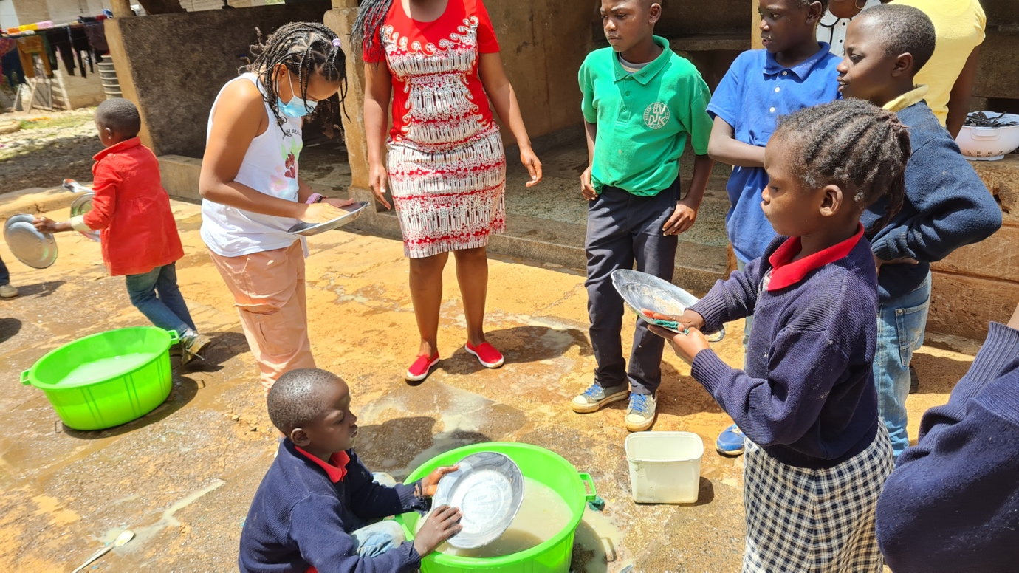

Proposal

Our GSL Team needs the support of the Rusinga School community to help raise funding for some of these challenges:

Need | # Children | Price (Kes.) | Frequency Annually | Total Cost
Milk per 50ml | 194 | 6 | 208 | 242,112
Beef per 50g | 194 | 20 | 52 | 201,760
Chicken per 50g | 194 | 20 | 52 | 201,760
Egg per unit | 194 | 15 | 52 | 151,320
Detergents per 250g | 137 | 50 | 12 | 82,200
Bathing soap per piece | 137 | 50 | 12 | 82,200
Bathing sandals per pair | 137 | 100 | 1 | 13,700
School fleeces per unit | 194 | 1,000 | 1 | 194,000
Theatre costumes | 50 | 1,000 | 1 | 50,000
Grand Total |  |  |  | 1,224,752

Conclusion

Our GSL Team is required to raise funding to meet some of these needs by 1 May 2023. Considering that the time is short, our Team can only select and focus on a few of these needs based on priority. Therefore, we decided to select detergents, bathing soaps and sandals because we felt that they would support Shangilia in the most effective way. Our GSL Team is planning to raise funding to buy a supply of these items to last a whole year (12 months), which brings it to a grand total of Kes. 178,100.

We are planning to raise this amount through various ways including:
- bake sales including one that we are planning to hold at school from 19-21 April 2023
- fundraising activities involving both students and parents in the final week of April 2023
- future fundraising and outreach activities involving the Rusinga School community throughout the year

Need | # Children | Price (Kes.) | Frequency Annually | Total Cost
Detergents per 250g | 137 | 50 | 12 | 82,200
Bathing soap per piece | 137 | 50 | 12 | 82,200
Bathing sandals per pair | 137 | 100 | 1 | 13,700
Grand Total |  |  |  | 178,100

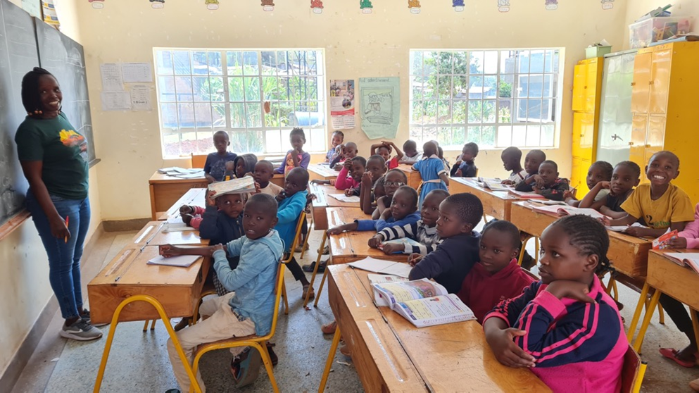

School Fundraiser

Fundraising @ School & on Loresho WhatsApp Group

Flyers

In our fundraising stages we sent flyers to both our schools’ parents and our small communities WhatsApp group which were both willing to support Tumshangilieni.
As we haven’t summed up all the money we have made, we do know it will certainly be able to help the 137 kids in Tumshangilieni in the sanitary aspect so for a whole year they will not need anymore. The items we are fundraising for them are detergent, bathing soap and sandals but we are simply asking parents for their money only. We have requested for Mental Health Counsellors which could dedicate their time in one or two weekends, we have already agreed with our school counsellor to do so. We have also started a toys and clothes drive which we haven’t fully organised but are planning to do so as soon as possible.

These are some of the flyers we sent out to parents and our communities WhatsApp group:
: 