For a few months, we, a few polish students, Oliwia, Krysia and Malika, have been taking part in a Global Social Leaders competition. Our project was inspired by the situation in current times in which everyone talks about climate change and how it’s dangerous, yet very little is done about it.
People often say there’s nothing they can do or they don’t know how they can make a difference in this fast changing world. We want to stop this mindset and increase the society’s awareness about climate change. The issues we thought are relevant to tackle are: climate action, life on land, sustainable cities and community.
But the first thing we had to do was to decide what we will do to make a difference. We chose planting trees because it has many benefits for not only the environment but also for people’s well-being.
The second important step in creating a team was naming it. We had a lot of ideas and finally we picked ‘Green Heaven’. After that our graphic manager has designed a logo and a poster for our group.
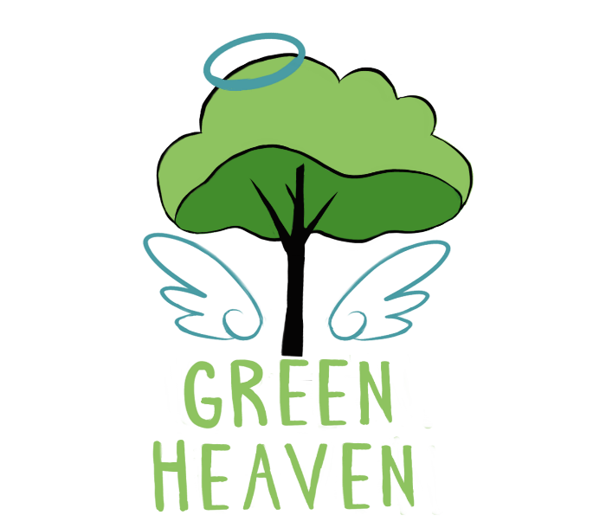
We came up with a plan for our project. The first step we had to take was to collect money for the seeds. Our group wanted to make about 1000 PLN We decided to make 4 bake sales in our school. In the end 3 bake sales were enough to earn the needed amount. During this fundraisers we put up the posters around our school, handed out flyers, we also didn’t use any disposable cutlery. All this this to promote our idea and spread the word about climate action and lead by example.
Second of all the type of tree we picked were Oxytrees. We can afford 20 of them. According to Oxytree site they would create about 5000 pounds of oxygen a year.
The planting season in our country is during March and April and unfortunately due to the COVID – 19 outbreak there is a quarantine in our country. The planting season in Poland occurs also in autumn so we will plant the trees as soon as possible. We are really looking forward to that.
During the process of making the project we have gained a lot of useful skills. During the bake sales our organizational skills were put to the test since we had no experience in that area. We improved our cooperational skills both inside and outside the team.
Wee managed to establish a partnership with a project of our classmate “ W.R.O.N.A”. We also learned to manage our funds and money well. Our project required from us to develop our diplomatic skills. We became more open-minded and solving problems within our group is much easier now.
We hope our project will inspire and encourage children and younger generations to follow our steps and care for our planet better than previous ones. We think that the whole city will benefit from our actions because planted trees will decrease the amount of carbon dioxide and will make the air much cleaner. We believe that even the small step will make a difference.
