Little Linguists Written Report

Our group, the Little Linguists, have undertaken a challenge to spread our enthusiasm for languages through workshops that we’ve run in infant and primary schools. We gave lessons about language and culture in: Mandarin Chinese, Japanese, Spanish and French.
The little linguists team has been tested in many respects during this project. All of the members of the team have gone through basic training in teaching, in addition to gaining vital organisational skills. When teaching, each one of us had to be charismatic, engaging and enthusiastic in our approach to delivering the lessons. Furthermore, this project has been a fantastic opportunity for us to revisit some languages we hadn’t spoken in a while. I believed that everyone has gained valuable public speaking skills too – primary school children can be the harshest critics.
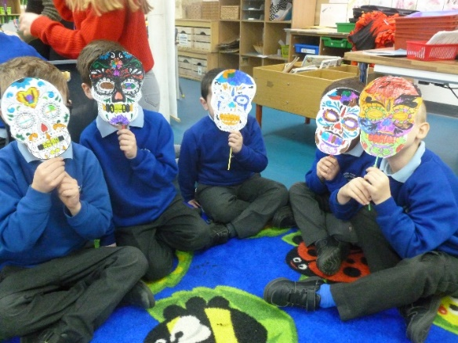
Over the course of our workshops, we have been very much intertwined with the local community through the impact and ‘buzz’ that our project has created. We have learned that the community really supports their young people in creating and carrying out projects like our own. All of the people we have contacted have been thrilled to have us and have been surprisingly very collaborative on how to best suit our template workshops to their school and students.
Initially, Dan and Emily found out about the development goals through the ‘Festival of Leadership Day’ at Wellington College. After forming a team, they shared what they had learnt and how this had inspired them to put their idea into action. We have held many meetings during our free time to collaborate and improve on previous ideas and create all the resources for our workshops.
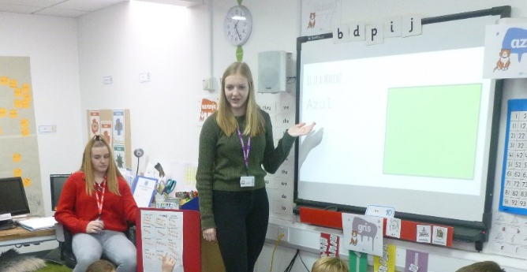
Our project has addressed the United Nations global goal of providing better quality education, because we helped to provide language lessons to young children (5 to 7). Language skills are highly sought after by employers, and by starting lessons earlier, and making them more accessible, we are increasing the chance of students becoming multilingual, and therefore increasing their future employability gradually. Another way we measured impact was by how much the students we taught, learnt and how much they enjoyed the experience. At the end of our ‘Little Linguists Language Day’, we had several students come over to us, thanking us for the ‘Great Day’ and telling us that they ‘Had a really fun time’ learning about other cultures and languages. Additionally, a few weeks after the day, we received a card, handmade by the students, thanking us again – in Chinese! At the end of the day, we held an assembly where the students presented their new knowledge to their peers and teachers and afterwards some of the teachers commented that the amount of learning the students done was far more than would be expected in a single day for their age group.
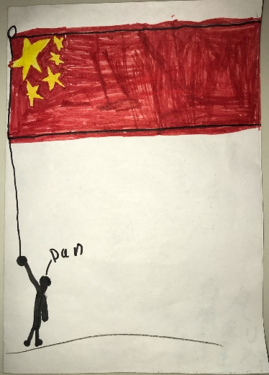
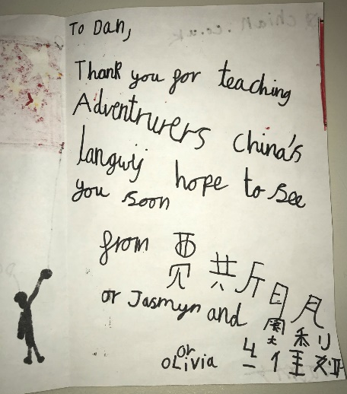
Overall, we impacted around 120 students, 15 staff members and 1 school with our project, directly, with many other students also benefiting from the outcomes of the project: the school has really taken a great approach to languages and looks to work with us again in the future. Moreover, we are planning to do more workshops in different schools too, which will result in us impacting nearly a thousand people by the end of the academic year (students, staff and their families). In total we spent around 200 man-hours, working on our project, and this included meetings with our team and the school, planning lessons, training and actually doing the workshops.
We included many people in our project as we had the maximum amount of people in the group and because of this, we were able to create many unique ideas and bounce off of each other. Within our group, we were able to teach Chinese, Japanese, Spanish and French. When going to Cross-Farm, the teachers were also very involved with the activities and we even taught them a few things about each language, which they enjoyed very much. An example of this was students and teachers having a little conversation using phrases and hand gestures we had taught them in the French class. As well as this, some of the teachers took our resources to use once we had left to carry on teaching the classes the different cultures and languages. For the sustainability of our project, we have considered doing more work-shop days with Cross-Farm as or even creating an after school club for the summer once we have finished our GCSEs. They really enjoyed the day and have said that they would like the opportunity to work with us again. In addition, we have contacted other schools in the area who we think might be interested as we are open to do a few workshops after GCSEs. Another idea we have is to keep this project running within our own school so the next student leadership team could do workshops or even bring primary schools to our own school and use the resources we have at Tomlinscote such as the language teachers and PE equipment to make more interactive cultural games.
This project has really strengthened our personal connections with the community and has also allowed better inter-school relationships to exist. Thus, we have achieved our goals of 4) Quality Education and 17) Partnerships to achieve the goal.

