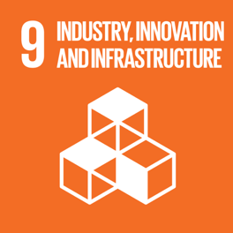
Background
Operation Clean Sweep
The idea for Operation Clean Sweep all began with a simple thought. After joining a club visiting an orphanage called Mwai, we members of Nali+ were touched by the sights around. The building was crumbling, walls that were faded and no electricity. The water had been cut off because of late payments, and yet this was all the children relied on. How unfair, we thought, that these children were forced to live under harsh conditions since birth and yet our families were privileged. And so Nali+ joined together in order to make a change to those precious hearts made to live in such upsetting environments.

Initial Plan
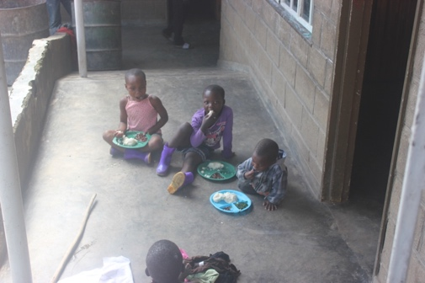
Nali+ doesn't only want to focus on the orphanage for a short period of time, but we choose to focus on it for an extended period even after the competition in order to ensure that every orphan would be able to grow up safe and healthy.
Our goals were to:
● Renovate the orphanage
● Provide them with long term aid
● Engage the community to provide them with employment and influence them to help their neighbours

What We Have Learnt
Spending time with everybody at the orphanage has taught us that they aren't just children with disabilities; they are children with hopes and ambitions.
18 year old Alice, who was born with legs that do not function, says that she wants to be a lawyer. In order to defend disabled people against discrimination and prejudice. 14 year old Happiness says she wants to become a doctor because of her pure love of sciences.
One thought crossed our minds when we first arrived at the orphanage. "If I didn't have the mum and dad I have now...this could have been me." Circumstances you are born with can change the way you are able to live your life. But it's important that we don’t let unfortunate circumstances to lead the path of the rest of our lives.
Everybody deserves to have their dreams come true. And just because they were born different from most or because they were born without a stable support system, does not mean that their destiny lies in that same path. It's never where you are in the beginning of a race that matters. It's where you are at the end of the race.

The Future
A firm foundation has been built between Chikondi Disability Orphanage and Nali+ and we ensure that we will keep it. They have no aid from outsiders as aid has either stopped due to financial struggles, or the death of donors. With the Indian community and Lilowngwe sponsors supporting us, we are to be the primary aid system that Chikondi relies on. We intend on making sure that the renovations we make will be long loving as we will be there to revive any repairs that need it. We also choose to maintain communication with the children and owners of this establishment. A relationship has been formed. This bond we share is not to be broken.

Instant Impact
The greatest impact that we had was unity within the community. Everybody was willing to help and unified we achieved great work.
Our fundraisers elevated excitement amongst our peers and neighbours. With each fundraiser there was great communication and volunteering within school grounds and other corners of Malawi.
Busking in school grounds amongst our students and dragging the teachers to participate in teacher punishment raised us over k100,000 in total. Busking for the Indian community in Malawi raised us k50,000 in cash and k250,000 by donations through cheque! To add on to this, there were also great boxes of donations of children toys, books, clothing and more! Sponsors from our capital city supported us in our activities and will continue to support us in the near future.
During our visits to the orphanage we were welcomed very warmly by the children and Mr and Mrs Mussa who were delighted by our visits. The neighbours of the orphanage would often also join in with cleaning and washing. Soon after the clean, plans were made and men from the community were hired for construction work. Togetherness will bring a brighter future for the children and help support the hardworking Mr and Mrs Mussa.

What We Have Learnt
Spending time with everybody at the orphanage has taught us that they aren't just children with disabilities; they are children with hopes and ambitions.
18 year old Alice, who was born with legs that do not function, says that she wants to be a lawyer. In order to defend disabled people against discrimination and prejudice. 14 year old Happiness says she wants to become a doctor because of her pure love of sciences.
One thought crossed our minds when we first arrived at the orphanage. "If I didn't have the mum and dad I have now...this could have been me." Circumstances you are born with can change the way you are able to live your life. But it's important that we don’t let unfortunate circumstances to lead the path of the rest of our lives.
Everybody deserves to have their dreams come true. And just because they were born different from most or because they were born without a stable support system, does not mean that their destiny lies in that same path. They can have the chance to change how their lives started. It's never where you are in the beginning of a race that matters. It's where you are at the end of the race.

Our Team
Nali+ is a team made from the literal name. "Nali" standing for the combination of the team leaders Nidhi and Talandira. With the best friends and family Tawonga and Tamanda. Not to mention the trusty help of our teachers Mr Gunda, and Mrs Wagner. Who supported us, advised and also pushed us on to finish this competition.

Thanks
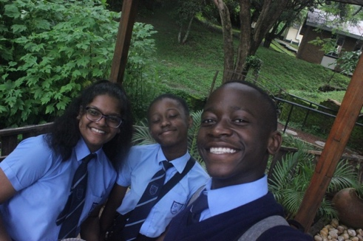
The Global Goals competition was our first opportunity to pull our socks up and make a change. Often, we would tell ourselves that three 15 year olds and a 17 year old couldn't actually change the lives of a whole orphanage of children. But after raising funds of over k350,000 and being able to engage the community and spread awareness of aiding this organisation, we realise that as long as we try... we CAN. So thank you to Global Goals, for helping us realise that it is possible to make a difference.

