#OVHTBH (Our Voices Have To Be Heard)
At Olashore International School, a number of us – students, came together to ‘see a difference’ through this movement. We are Unuma Michael, the project leader; Ayibatare Ebaretonbofa; Azoom Sedoo; Chidi- Ogbaji Chimdalu; Olalere Chidera; Olalere Olafisoye; and Unah Sophia.
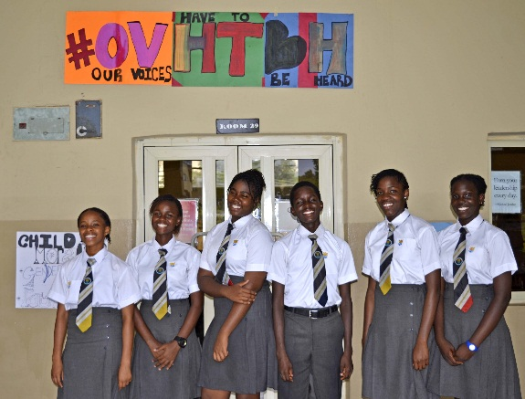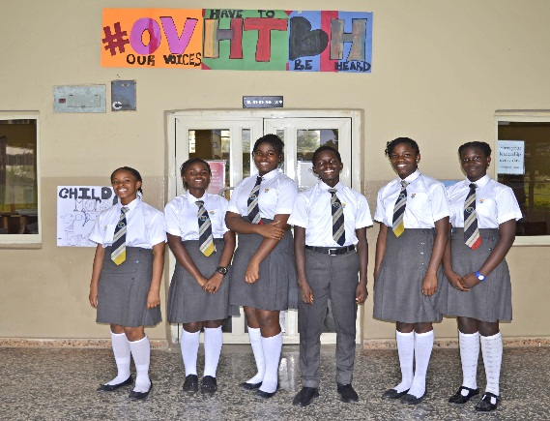
This competition was to fulfil the GSL aim of making children understand good child citizenship and how to bring their ideas to reality. From the moment we had insight on what we were in for, we conducted some research; we called ourselves Olashore International School [name of our school]. The research showed us that a major problem in the world is concerned with issues bothering children, such as child abuse, child labour, child poverty and the sort. We decided to add child poverty to this, because we realized child labour, child abuse, which are technically different, attacks those who are under privileged, but if our team could educate these people at focus, we could teach them to know they have a right to education and they can only get this if they speak up for themselves, and as one. They should know that being poor at hand should not be allowed to grow into being poor at mind. The school is very crucial, but education doesn’t come only from school. What we learn at home from our care-givers count as well and is education – knowledge, for education is what we see, hear, do, learn and do not forget. We wanted them to know it is only what you know, your knowledge, that can grant you success, and that material wealth is just an accompaniment. Nevertheless, one can only be poor at hand when one is poor at mind.
This brought about our campaign #OVHTBH (Our Voices Have To Be Heard). We aimed at managing the menace(s), while achieving as side that respects children, from the society and the children as well. We filled in the required templates and files as a group, expressing ourselves and collaborating well. Our project was approved. We soon realised the Sustainable Development Goals or Global Goals we were to observe based on our planned theme were Global Goals three, four, five and ten, which are Good health and well-being, Quality education, Gender Equality and Reduced inequality, respectively. We indicated the goals of Gender equality and Reduced inequality, because categorically we intended to teach on child safety and child morality. This was to educate them and empower the masses to use their voices. Morally, Gender equality is something worth fighting for, and we want children like us to maintain peaceful co-existence and not unhealthy discrimination. We were assigned mentors, who helped to keep track of our project growth, told us what they liked about our idea, and even what they felt could be done differently and better.
We arranged several meetings to talk about measures we would take to achieve, successfully and in due time, our project proper. We created team evaluation questions to track our progress. Below is a link to the presentation where this is contained; https://drive.google.com/drive/folders/1Spls0KklyK44xQEbfioC_zByfI88I5Tk?usp=sharing
We also arranged sessions with top management, the teaching staff and student body of our school. At this we shared our project aim and objectives and the part we hope they can play. At the meetings, each member of our team covered a specific area of the presentation in accordance to the outline we made. We were asked questions about the ability to effectively push our campaign, challenged and suggestions on other things we could do was proposed. We were also asked about the team structure and our collective efficiency. Finally we were praised for our efforts.
Apart from the blog that the coordinators asked us to make, we went further to create an awareness blog. The link is https://ovhtbh.travel.blog/. A lot of careful thinking went into planning and creating the blog. Olalere Chidera was assigned to handle the blog aspect. It was quite a long process.
On the 4th of April, 2019, at Olashore International School’s Leadership Centre, two consecutive meeting were held to inform the staff and student body of our school about the same issue bothering children and their roles to play in ensuring our voices our heard. To the teaching staff, we spoke about how they can ensure that their students are not abused and learn comfortably. We told them about our project and the aim of it all. Firstly, we played a video showing child maltreated for unnecessary reasons, then we spoke to them. Afterwards we shared questionnaires as surveys to know what they had to say and how well the awareness programme touched them.
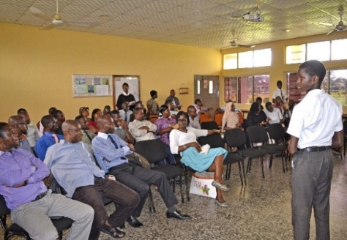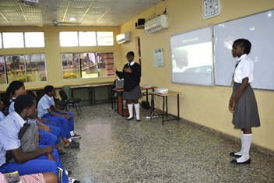
This is us speaking to the academic staff of our school.
In accordance to our school’s calendar, the students vacated for the Easter break and so did we. At home, we continued our empowering. We interviewed people on their view of the menace(s) and how one can overcome them, especially the less privileged. We also made posts as our feed on social networks like Instagram and WhatsApp for all our viewers and potential viewers to see, for we tagged our school, COBIS, Global Social Leaders and other respected personalities, encouraging all to share, repost, blog about, speak about, make videos on, and any form of mode of reaching out to the greater masses. We handed out fliers.
Back to school and we are still at work. In accordance with a target set by the GSL team, the team at Olashore decided to host a seminar for some children who live in our local community. We also then decided to host a play for them at the seminar which was supported by our mentors. So we delegated the story writing duties to some of our own, Unah Sophia, Azoom Sedoo, Unuma Michael and Ayibatare Ebaretonbofa, and roles were given to some members of the school body. The rehearsals for the program began on Wednesday the 24th of April and they concluded on Friday the 26th of April. The program itself was held on Saturday the 27th of April. It began at 9:00 am and was attended by 23 pupils and a teacher from 13 local authority primary schools. As the pupils arrived, the safety video which was designed by Unuma Michael as assignment, was played to interest them, teach them, and prepare their minds for the event. They were educated on child safety and were instilled upon good moral values. We spoke to them on ways to keep safe, like not walking alone, mostly at night, not going for late night parties; and they actually suggested a few. We had a task for the children which involved them answering a few questions.
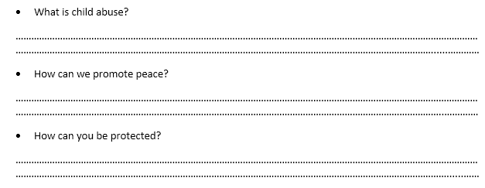
They watched the play which further buttressed that. The title of the play was “Misfortune” and it lasted for approximately twenty minutes. After the play, the programme continued with the children being educated on their rights. The event ended with the children being told what they could do to ensure peace and freedom. After that, the children and the team took a picture and then they left for their various locations. Below is the link to pictures and videos from these activities; https://drive.google.com/drive/folders/1viot-7ExHmtOhVXma2B0oUL-D9cKFDf4?usp=sharing; https://drive.google.com/drive/folders/1NLX7V1_NC5H2XTGMmMsiMTYoT1V-vL6c?usp=sharing
After the program with the children, ON THE SAME DAY, Olalere Chidera, Olalere Olafisoye and Unuma Michael left for our school hall to conduct our already planned information fair for school parents coming into the school for one business or the other. We put a notice board decorated with facts and action plans as well as the four global goals this group observes, all running against child abuse, child labour and the sort. We also shared to them questionnaires as surveys. We did the same on the 28th of April, 2019. The survey had the questions and requirements:
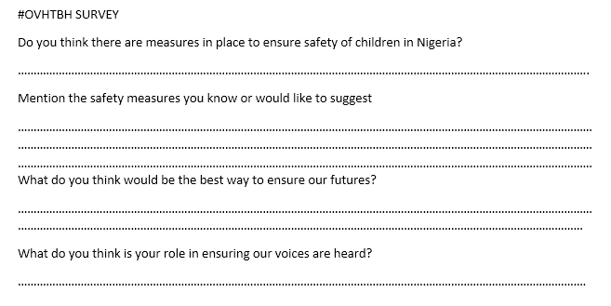
After this day, we gathered all the questionnaires we gave out, including those given to the children and the analysis is thus, the staff, student body and parents took the questionnaire above and in total were seventy; twenty-two parents, twenty-one students and twenty-seven staff. Twenty-three over seventy (33%), altogether, said yes to there being child safety measures in Nigeria. Twenty-four (34%) said no to it and twenty-three (33%) said yes, but not sufficient. For the children’s fifteen over twenty-three (65%) of them did not quite get the concept of child abuse but eight (35%) of them understood so well. This is us conducting the analysis.
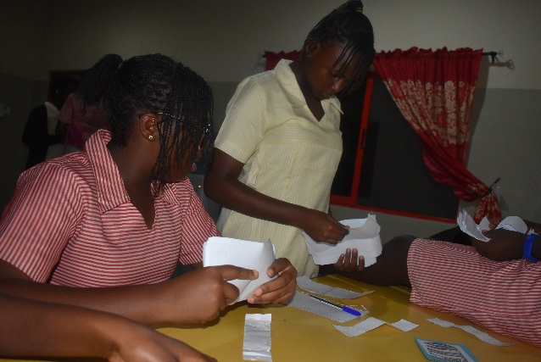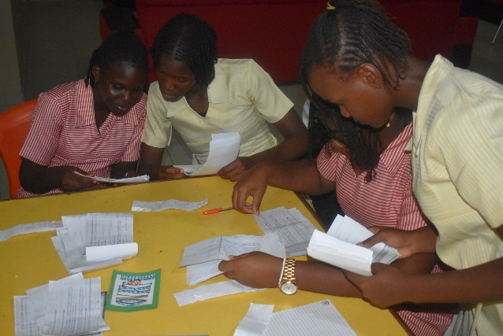
We are indeed glad for the entire experience and the number of people enlightened. We do hope that a lot of people view our posts and let our voices to be heard. We would continue to make good use of our social media platforms to speak against the menace(s) and we would let our blog survive, continue to blog post and enlighten anyone we can, taking every opportunity we can get.
Thank you.

