Nursery Renovation Team

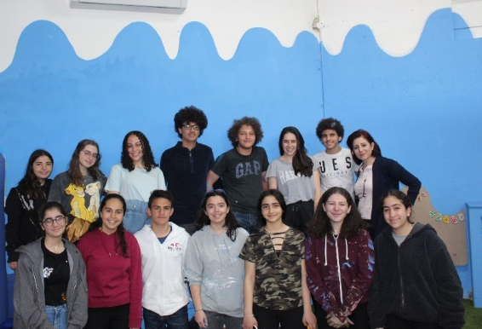
The Nursery Renovation Team from The Ahliyyah School for Girls and Bishop School for Boys is comprised of seven tenth grade students. Our goal is to renovate our school’s nursery and turn it into a more nurturing environment for the children. We decided to take this project due to the lack of space in the nursery as it is a very old building since 1936! This was done by re-decorating the space -re-painting the walls with a nature inspired setting-, providing the children with a fun and safe playing area -by installing interactive and educational toys on the walls of the play area this was to make a more efficient use of the space. This took a few months of planning, organizing, contacting required parties, then 7 renovating sessions, each session being 5 hours – a total of 35 hours of renovating!). This posed a major challenge as we had only this time to cover everything with nylon and prepare it for renovation, complete our tasks for the day, then fix the nursery and make sure it’s ready for the students coming in the next day.
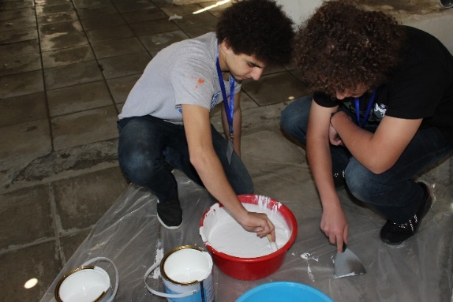
Our work changes the nursery and positively impacts the routine of everyone there. After receiving feedback from the nursery’s principal, teachers, and parents of the students who attend; we found that our renovation left the nursery more aesthetically pleasing, better organized and more comfortable for the students. “the students were very happy about the interactive wood boards, they enjoyed spending time and playing there. The paintings transformed the entryway magnificently, the painting of the nursery walls changed its appearance and gave the impression of a wider bigger space – less cluttered-. Also, after every session your team would clean up and organize the nursery to the way it was before you started working and prepared it well for the next day which made me very pleased” – Nursery’s principle, Miss Maysa Haddad
We learned about different subjects such as digital design softwares, finance, and about project leadership, as this whole renovation is managed by our team and we led a group of 15 volunteers each renovation session. We have also developed skills, that are essential not only to the success of this project but to our success as individuals in the future such as: communication, creative and critical thinking, and time management. Participating in GSL Global Goals Competition boosted our self-confidence, as none of us thought we were capable of managing a project of this magnitude with minimum interference from supervisors. We learned the specific skills needed during the renovation process such as mixing paint, painting, installing wood pieces and others. We also benefited from the theoretical knowledge and skills, for example writing reports, and requesting a sponsorship.
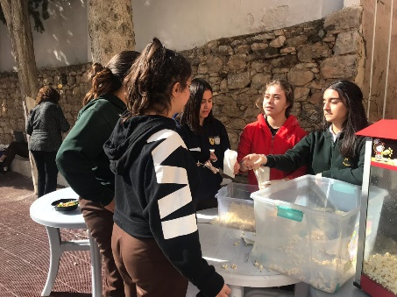
After drafting our budget sheets and determining the approximate costs for the completion of this project, we began raising funds through different channels. Firstly, we organized popcorn sales during break time at school, we held a free dress day where each student that participated in the free dress payed 1JOD. To raise the rest of the costs needed we contacted the Housing Bank “Bank Al-Iskan” with a sponsorship request. After a period of negotiation, we received a 1000JOD sponsorship to cover the remaining expenses.
While planning and executing this project we were guided and focused by the Sustainable Development Goals (SDGs). We researched the correlation between quality education (goal #4) and proper learning environments and found certain attributes that are needed to elevate the level of learning and student’s ability to acquire information or develop basic skills. For example, during research we found that nature-inspired designs play a big role in child development, and shows a direct connection with improved motor, social, and creative skills which are essentially developed at a young age. Hence the color theme of the nursery’s walls (white, blue, and green). We also insured that all materials used are eco-friendly, and long lasting. To further our contribution to goal #4 we built a small library at the nursery, to encourage reading starting from a young age, also to support the students in order for them to develop their skills and imagination.
Through the 35 hours of renovating, and months of planning we experienced so many memorable, fun moments. As well as times where we fell behind on our schedule due to the load of school work. Yet the highlight of the journey definitely was the last renovation session and the pride everyone felt for being a part of and completing such a project. Submitting each report and completing every task was an unexplainable adventure highlighted by the teamwork and lessons learnt throughout. We faced many difficulties during the renovation itself, the most prominent challenges are: working around the safety cushions that are placed around the edges of the walls and finding time to finish all session tasks. The key to solving these issues was a detailed plan and specific tasks for each session.
At first the school administration was hesitant to launch such a project. A high magnitude renovation to the nursery is a challenging project considering the funds required, and the difficulty of finding time to work considering all the holidays and the fact that it was occupied by students and teachers every day. Yet as the number of children at the nursery increased, the renovation became a must to enhance the use of space in the play area, and that is where our team came in, and took on this project.
The renovation not only effected the nursery, and us as a team, it also connected our community, as it included students from grades 8-10 working together alongside teachers and faculty members, all who are taking time and volunteering to help in order for us to reach our goal and enhance our environment. Various teachers came to assist in overseeing the organization of the renovation sessions, as well as students who attended to participate in the process. Our collaboration led to reaching our aim and completing the nursery making it better for all those who attend it and helping to make them more comfortable as they move through their daily routines. We must also include our supervisor Miss Reem AlSawalha, all school faculty members who took part in the success of the project during its different phases and not only the actual renovation. As well as the housing Bank which was a major contributor to this team. This project was the astounding outcome of a priceless educational experience, completed by a hardworking team and collaborative community.

