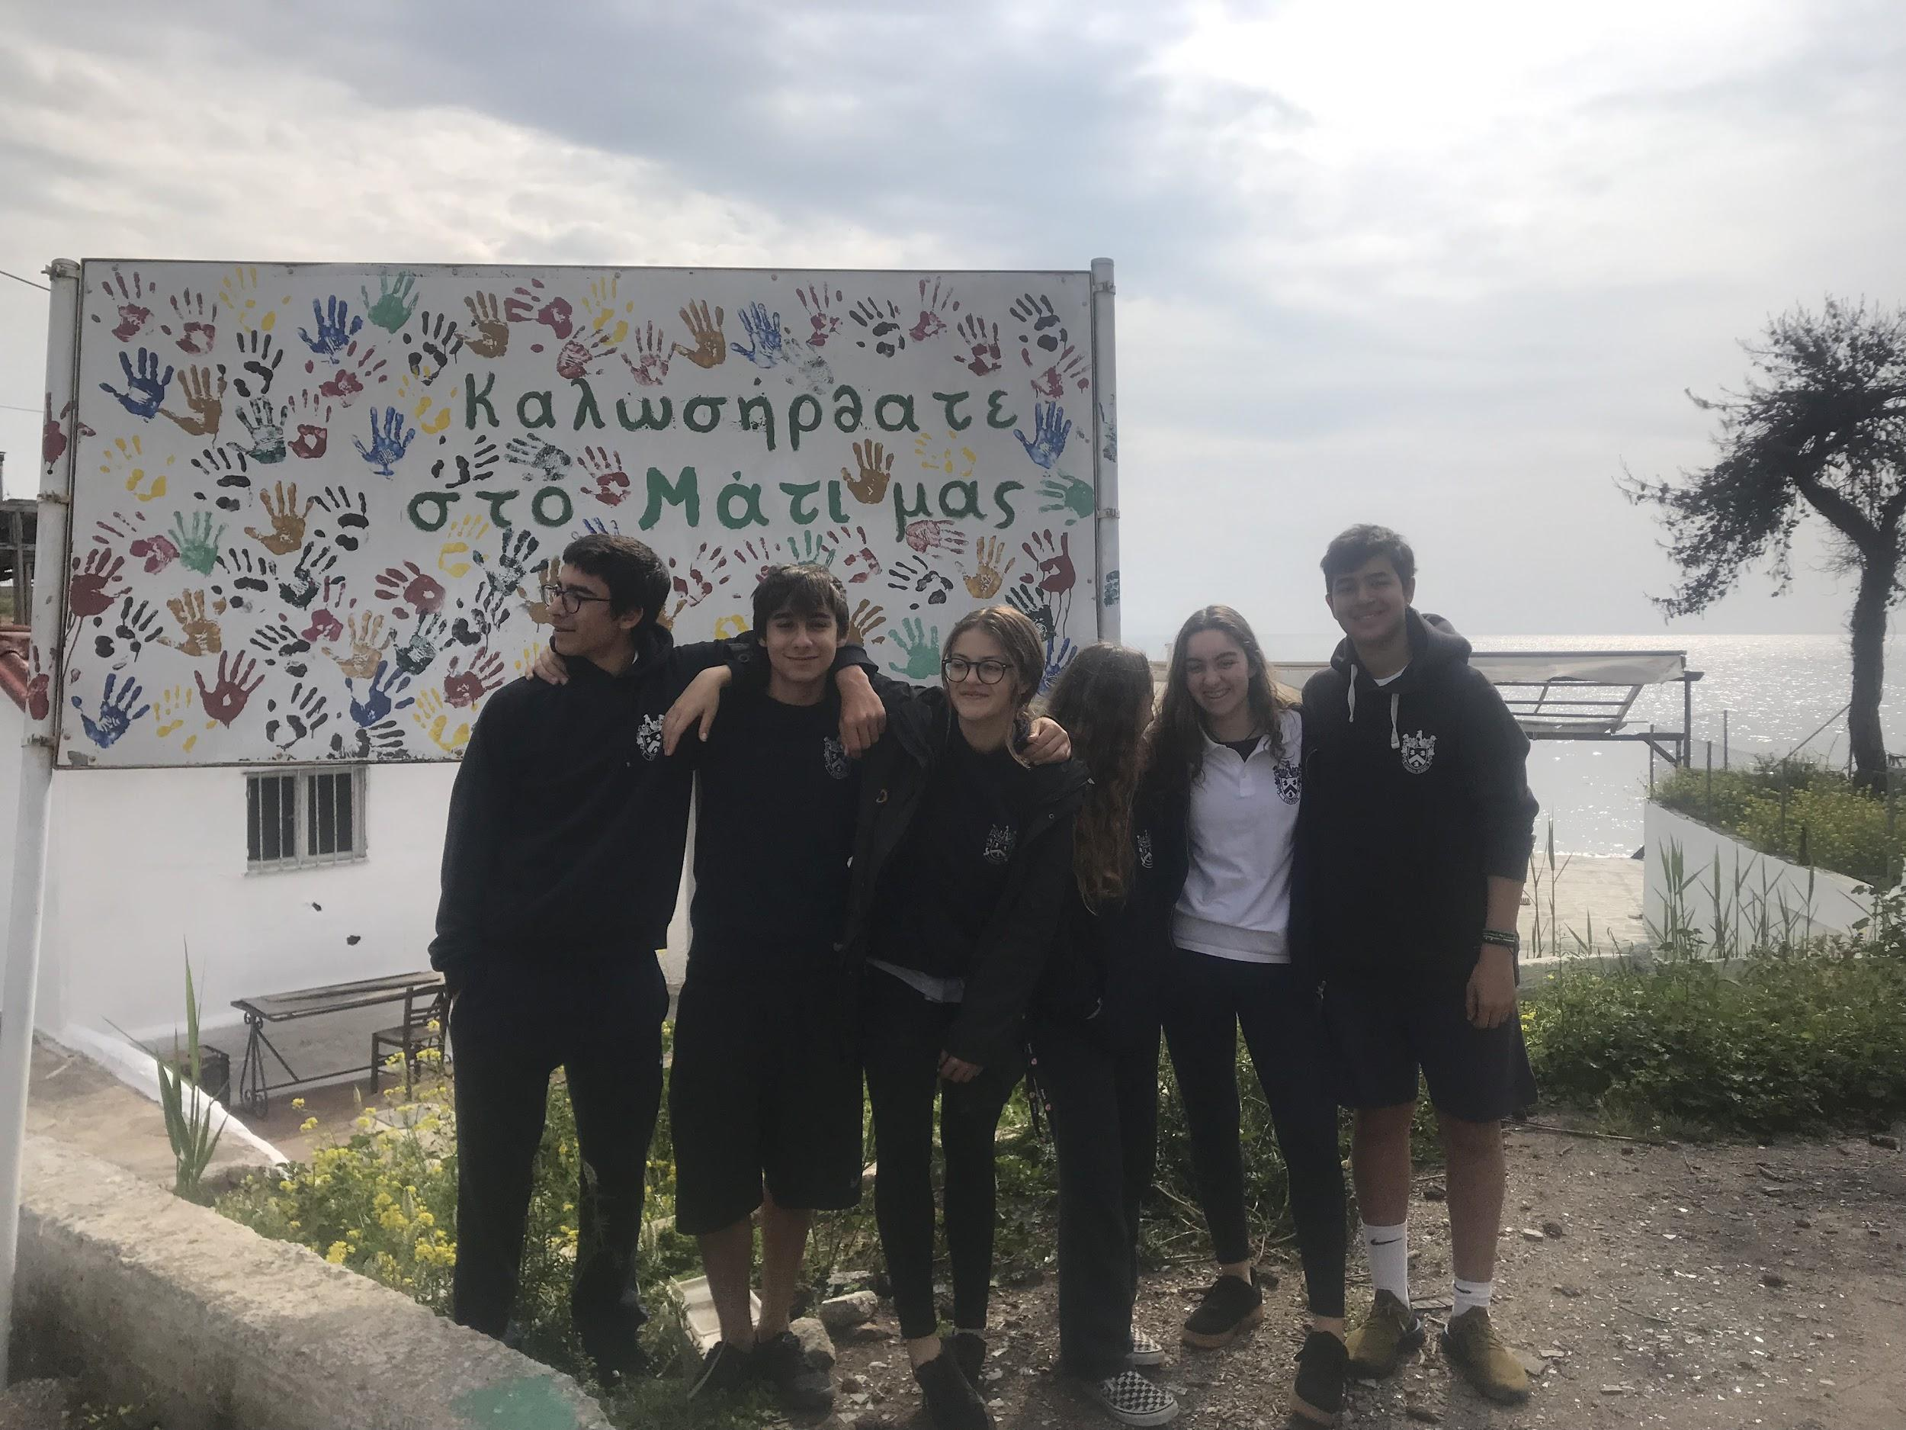
LIFE ON LAND: MATI PROJECT
Campion School,Athens,Greece.

Team Members: Constantine Michalopoulos (team leader),Gaia Mercuri, Kostantis Argyropoulos, Natali Amarilio, Arda Yuzak, Iro Delidimitri
Digital Report:https://docs.google.com/presentation/d/1uiKQ-S5O-lKJC9JAgspb2ou6pJiuUhQ5K1QzGqz6cc8/edit#slide=id.p

During our third term of school (January 7th-April 19th) we created a project dedicated to Mati and the people that lost close friends/family and their houses, because of the fire that took place from 23 July 2018 – 26 July 2018. Mati is a village in Greece, outside of Athens. It is located on the east coast of the Attica Region, 29 kilometres east of Athens;generally being a popular holiday destination. Our project was mainly aimed towards ‘Life on Land’ and raising awareness about fires as well as helping people and animals to re-settle in the region.

The village of Mati went from a family location and touristic location to ashes. The citizens were devastated and fortunately agreed to help us with our project. They were delighted with the fact that this devastating event was getting more attention and more people were willing to help repair the damages. Our ‘Mati Project’ aims were: Firstly, to create and evacuation plan in order to educate people so they can know what to do if another fire started as the main reason so many people died during the fire was because they did not know how to react. Another aim was to volunteer as much as we could as group in order to help the survivors because survivors are still suffering and are still dealing with all their losses.

A vast part of our project was working together as a team and combining all of our ideas to create a perfect outcome.

How we achieved our aims (Volunteer Work):

- We firstly visited the fire department of Mati and discussing the damages and how they took place, with the fireman in charge. He gave us a thorough tour of the fire station and explained the causes of the fire. He showed us the different instruments to prevent fires and how to use them.

- We then organised a trip to Penteli, close to where the fire started. We spent a whole day there planting trees and spores around the mountain. We managed to plant 190 trees and approximately 85 spores.
- We then went to Mati, in order to feed and take care of animals which were hurt by the fire. Many people fled their homes but left their pets so they are many strays which are in great need of food. Also some animals are hurt and we took care of them.

Raising Awareness:

- We presented our evacuation plan to the Campion junior school.
- We found this very important because the main cause of the deaths was that people were not correctly educated about fires. So by presenting our evacuation plan we managed to “save” people from future fires.
- We told the kids that they should “Stop, drop,roll”, during a fire.
- We also put posters around the school in order to educate the school on what we were doing.
We intend to stay in contact with the Mati community and collect data in the following months to see how our actions impacted the community life in order for us to see the long term effect. We are delighted to see that the students got very emotional about our project and are eager to help. In general all the students in our school are aware about our project and enthusiastic about it and willing to help furtheer. We will remain seized upon the matter.

