GSL Competition: Written Report

Untitled Space
Ka Yeon Kim, Sarah Azhar, Sarah Liaw
British International School of Kuala Lumpur
Endless. The concept of having an untitled space is often comforting with its limitless
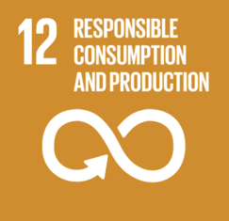
possibilities. By unlabelling ourselves, there are no limits as to what we can achieve in this project, specifically focusing on the 12th global goal to promote a greener lifestyle by minimizing wastage and consumption, particularly within the school community.

In support of our project, we began by hosting a second-hand store during the Christmas Bazaar in which we collected donations from the public and repurposed them in order to lengthen the lifespan of various products (namely school uniforms), which would otherwise have ended up in a landfill. Through this experience, we gained valuable enterprising skills and included others in the school community by accepting volunteers, allowing the public to gain an understanding of the importance of sustainable living. During this sale, we managed to raise funds worth around GBP 100 which went towards supporting charities that promote sustainable lifestyles by minimizing use of non-biodegradable plastic products Tak Nak Straw. In return, we were able to invite the organization to conduct a workshop during Earth week, teaching students how to convert paper into a multitude of products including straws and cutlery. We received positive feedback from students and hope to continue leaving a positive impact on our school community by encouraging the adoption of eco-friendly habits.

Testimonial: “This was a fantastic opportunity to learn new craft skills and help save the planet at the same time! I will definitely look forward to more workshops and events like these and share this newly-acquired skill with my friends and family.” – Attendee of workshop

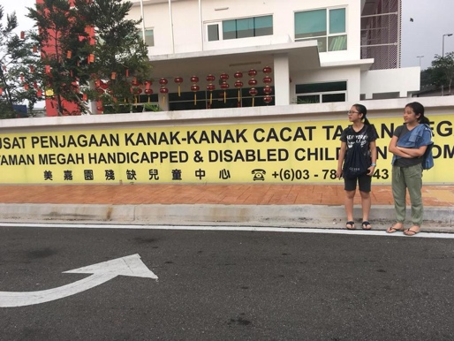
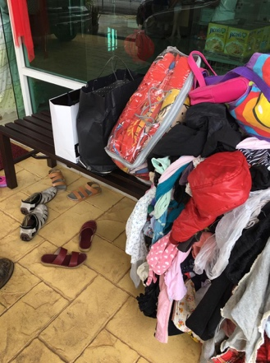
After the second-hand sale, we had some leftover items which we donated to local orphanage and disabled home - PPKKCTM. During our visit we interacted with the children and residents and taught them the importance of a sustainable lifestyle and how they could implement this within the home. In support of this, we donated reusable plastic cups and cutlery which could be used in place of some of the disposable products that were being used at the time. This was a particularly interesting experience as it exposed us to the real world and allowed us to see impacts beyond the school community.

Over the course of the competition, one of our highlights was seeing the community in action and contributing to a better future by participating in the events that we organized as this allowed us to realize that all of us are responsible for Planet Earth and its survival as well as the importance of teamwork in achieving the SDGs. Although we initially found it difficult to find a way to impact as many people as possible, we eventually overcame this obstacle by making our project and its management available and open to the rest of the school by hosting workshops and accepting volunteers to help organize inter-school events such as the Christmas Bazaar sale.

Overall, we believe that we have managed to make an important contribution to society and though the journey ahead may be long, we hope to continue to support this initiative in the future and further integrate our values into the lifestyles of students around the world.

