BSAK ECO INNOVATORS - GSL COMPETITION:

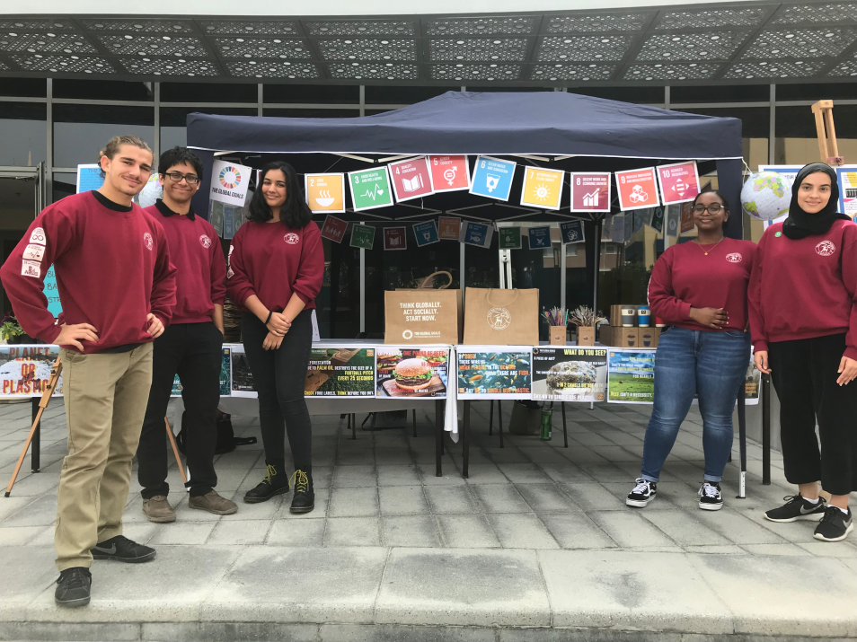
The UAE is a country unlike any other.

Its transformation from a barren desert to a thriving economy in under 50 years is a testament to its leaders’ ingenuity and foresight. Its ability to accept all nationalities and cultures without compromising on its own fundamental beliefs is an achievement that only a handful of nations can claim. But the country is not perfect. The UAE has one of the largest carbon footprints in the world as well as one of the highest obesity rates. We wanted to change this nonchalant attitude towards our environment and personal health and thus, on the 9th October 2018 the BSAK Eco-Innovators was established.

We chose goals 3 (Good Health and Well-Being), 11 (Sustainable Cities and Communities) and 12 (Responsible Consumption and Production) as we believed that by pursuing these we would be able to have the most significant impact on our community. A few days into the project we quickly realised that the most effective approach to making a change would be through education. We believed that if we changed people’s mindset towards their health and the environment the results would follow.

Therefore, we decided to meet the senior leadership team in school and pitched a number of our ideas to them. After this meeting we streamlined our ideas to a more achievable list. Our aims were to; assist in designing a brand new primary dining hall within the school that promoted mental and physical wellbeing whilst being environmentally friendly and sustainable; to reduce our community’s waste (specifically single use plastic) by encouraging people to purchase items with sustainability in mind; to educate the local community to improve their health through awareness campaigns.

Dining hall:
We researched ways to make the hall more environmentally friendly and sustainable, then pitched our findings to architects from the London based company, Hawkins Brown, over Skype - this indicates our focus on goal 11. The architects took on board our suggestions and will now be incorporating them into the final build over the 2019 summer holidays. This includes using sustainable FSC approved wood; designing a bright, welcoming mural on one feature wall based on the local mangroves; a picture rail to hang up artwork and motivational quotes; buying an atmospheric water cooler to reduce water use and plastic waste; surrounding the hall with ample greenery; combining rectangular and circular tables to encourage more social interaction; only using ceramic plates and metal cutlery instead of disposable (focusing on goal 12); natural lighting and energy saving lights; automatic air conditioning timers; energy efficient dishwashers and ovens. The bright energy and atmosphere in the room will hopefully improve the children’s moods and mental health, relating to goal 3. We also recommended the school to use smaller plates as this would help to minimise food waste and also make sure students were not overeating, thus touching upon all 3 goals.
This project has been inspiring for us as we have had a say on an important aspect of primary children’s everyday lives, and have pushed the architects towards a more sustainable building. It also means we are leaving a legacy behind! It has been an amazing experience which has encouraged us to think innovatively and improve our presentation skills. We found it encouraging to have professionals (from a third-party company) listen to, accept and take on board our ideas. It was not that the architects were not aware of sustainability - they had just not put enough focus on it. But after we put them on the spot and made them critically evaluate their sustainable options, they told us that we have inspired them to have sustainability at the forefront when working on their next designs. Thus, we have been able to make an impact on the wider community.

How we have decreased waste:
We spent most of our time attempting to decrease school waste through various methods. Firstly, we decided to educate ourselves further by attending two conferences at NYUAD: Precious Plastic, which focused on the perils of plastic and how to reduce using it; and Arctic The Last Frontier, which focused on the effects of climate change and how to stop it. Following this, GSL Aamina Mohamed carefully crafted 13 factual posters that are now permanently framed up within a pivotal point of the school, where thousands of different people walk by everyday. They embody messages that challenge single use plastics, frequent red meat consumption, deforestation and climate change, indicating our focus on the need for goal 11 and 12.

Moreover, we removed single use plastic cups available at every water dispenser from the school premises. This was after liaising with the Junior Leadership Team and Senior Staff. We told pupils about this change in their respective year group morning assemblies and talked to them about the negative effects of single use plastic. Now, we are proud to say that most students and teachers carry a reusable water bottle with them at all times, due to the impact that our talk in these assemblies and the posters had on them. This experience was very beneficial as it allowed us to greatly improve our public speaking skills and gave us the opportunity to interact directly with many members of our community. During these conversations we realized that whilst people may meet any change with resistance initially in the long run they will adapt- especially if it means helping the environment! As a result of this initiative, we have not only significantly reduced the amount of plastic used by our school but also helped to change the unsustainable habits of the member of our community!

The annual School Fete occurs every February - we knew we had to take the opportunity to promote our message of sustainability there, since this was a community event with people of all ages and backgrounds attending. We realised that because of the 13 posters that were put up in school and education, many people knew about negative effects of waste on the environment, so we focused on providing easy access to sustainable alternatives. This prompted us to create 5 posters promoting ‘green’ brands which sell makeup, clothing and food, as well as sustainability habits and everyday objects that can be incorporated into people's homes and activities. These posters were also sent online to all students and parents, to provide them with instantaneous access of where to shop better, as well as being on display at BSAK’s main entrance.
Additionally, we produced hundreds of customised reusable bamboo bags, coffee cups with the Sustainable Development Goals’ and BSAK’s logo printed on them, metal straws and plants - we created these using some funds our school provided us with. They all sold out within the first few hours of the day, leaving us with an amazing sum of around 5000 AED. Making these products has encouraged members of our community to take the bags we made with them when going shopping to reduce single use plastic bag usage. They have also been taking their mugs and straws with them to coffee shops as a replacement for disposable cups and straws, thus having a great positive impact on goals 11&12.
We also had two interactive games which were a great hit on the day. The first one was fishing a duck from a pool full of plastic items; this was to act as a metaphor for how fish in the ocean are completely surrounded in plastic, and how we need to protect them. Our second game was knocking over single use plastic water bottles with a stress ball painted as a globe; this acted as a metaphor for how the problem of single use plastic water bottles should be tackled by the world. Both games had a resounding effect on both children and parents alike, who asked questions and offered their support. In fact, many of them made pledges to try and eliminate single-use plastic from their lives all together. These shocking visuals helped spark an ember of change in many people’s lives and we are very proud to say that it is quickly developing into a raging fire (that is sustainable of course)!
We are planning to use this profit in renovating a bleak, dark, desolate area outside into a ‘Global Social Corner’. We have sourced a company that makes benches made out of reused wood pellets, and would like to paint the walls around it in fluorescent colours with inspirational messages, focusing on the Sustainable Development Goals. This would improve the health and well being (goal 3) of pupils since the area will be more aesthetically pleasing. It would also act as a constant reminder to the hundreds of children that walk by everyday to think of the Global Goals, and strive to make them possible.

What we’ve done to promote:
We have continuously sent out messages in the Headmaster’s weekly newsletter to parents, posted our frequent achievements on @BSAKGSL twitter, and made recurring appearances in assemblies throughout the whole school to inform them of our plans. We have also written a professionally designed booklet about what the GSL are, what we have done, and how we have achieved it, which was sent to all BSAK community members. Moreover, we’ve written three blogs that are available on the Global Goals website documenting our journey. We also have a notice board in the school corridor which we regularly update.

Earth hour:
A global event that we pushed our school to participate in was Earth Hour. We added it to the curriculum for KS3 geography students, designing a compulsory lesson for them, and sent out an informative powerpoint to form tutors to show their classes. Following this, we gave an assembly to Year 3-5 Primary School students and explained what climate change is, how it is occurring, the effects it has already had on the planet, and what they can do to help stop it - we also played an interactive game which informed children how much water was used to produce food products, which shocked them. We chose to present to primary school as we believe that they are the future, and that educating children from a young age will mean their passion for the environment grows as they get older and start to make a bigger difference. Throughout the rest of the week, teachers began to email us with what each child in their class will be doing in an attempt to be more sustainable. We also took pictures of around 100 children and what they had done to save the environment - to see young children attempting and wanting to make a difference made us feel proud of our efforts .
Earth hour was a great success. Most teachers reverted to textbooks as opposed to using their smart boards, opened blinds instead of lights, and encouraged students to take of their jumpers instead of turning on the air conditioning. A few teachers even kept their lights turned off all day! There are photos all over BSAK’s social media promoting what classes have done for Earth Hour.

Surveys:
In order to measure our impact on teachers, students and parents, we sent out multiple questionnaires throughout our journey to see if the messages that we have been so focused on promoting actually had an impact on their everyday lives. We received an average of 300 responses for each survey. The first survey we sent was at the beginning of our journey (before we had made any public appearances) and focused on people’s habits towards sustainable consumption. We then sent out the same one towards the end of our journey, to measure our success and see if we had changed people’s mindsets. Our results had improved: 20% more people said they ‘sometimes’ used plastic bags, meaning they thought twice about their actions; 10% more people said they ‘never’ use plastic straws; 10% more people said they eat red meat ‘1-2’ times a week, instead of 3+. Around 60% of people gained the knowledge to change their habits through our factual posters and informative posters, indicating we had made a difference to our community.
We also sent out a survey to teachers on their photocopying habits, asking if they always photocopied double sided, or reduced two A4 pages on to one, and how they would reduce their photocopying as the amount of paper photocopied within our school was huge, and sometimes unnecessary considering we are living in the digital age. We are working with our school’s Head of IT to make photocopying double sided the standard function, inform them on how many trees they are cutting down individually, and the number of papers they have photocopied in the hopes of making them think twice.

The highlight of our journey - receiving a letter from the one and only Sir David:
Apart from the continuous uplifting emails from the Global Social Leader’s headquarters, the highlight of our journey has to be our letter from Sir David Attenborough himself! His words were extremely kind and encouraging; we were all ecstatic to hear he had replied to us after we sent him a letter informing him about our journey and how changing people’s mindsets was extremely difficult. He reminded us how ‘all of us need to work together’, which after a few negative comments about how us five GSLs will never be able to make a big enough global impact, really motivated us to keep going. We gave assemblies on Jadev Payeng, who single handedly transformed a barren landscape into a thriving environment. This changed the mindsets of students and helped them understand how anything is possible as long as you have the passion for it.

Health Campaign:
With regards to goal 3, our team has collaborated with the school’s Sixth Form Medical Society in order to create a health campaign during June. We have decided to focus on the importance of sleep, and healthy eating, and will work with them to create informative posters to aid people in improving their health. We will promote these by hosting our own version of a Ted Talk during one of our lunchtimes where everyone will be welcome to come listen.

Knowledge/skills we’ve gained:
Throughout our journey we have gained many skills that we would probably not have had the opportunity to develop otherwise. Due to the need to get our message across effectively we did four assemblies to a variety of ages across primary and secondary - this allowed us to develop our public speaking skills, and the ability to alter our presentations to make our message clear for different ages. In addition to this our presentation skills were developed as we had to pitch multiple ideas to a range of professionals including senior staff and architects. Our organisation skills were also developed during this process, as we had to balance everything we did for the competition along with our A Levels and other extra curriculars. At the beginning of this journey, us five GSL had never worked with each other before - this process allowed us to work on our teamwork and communication skills, and it is safe to say that we are now good friends who have enjoyed every single moment of this journey with each other. One of the most important skills would have to be our resilience - although we were knocked down by fellow pupils in school, we always came out stronger as a team; when a few people began to say we wouldn’t make much of a difference, we did something great and ended up having children come up to us telling us what they were doing to help the environment - times like these were so rewarding, and made everything feel worth it. As a team, I think we had forgotten this was a competition - we were not focused on winning, we were focused on making a difference in our community and protecting our planet. We even plan to carry this movement through to next year, whether we decide to enter the competition again or not.

We would like to specially thank Mrs. Mohamed for mentoring us through this journey and always supporting and guiding us through our endeavors. We could not have done this without you Miss!

