**Three Bin Battle**

**Aims:** to promote recycling on the school campus, to gain support from the senior management team, to influence other students to help out too

**Background:** Last year a friend of ours did a survey about the number of plastic bottles wasted per day in our school and the results were shocking. Out of 83 students 670 plastic bottles are used by them in a month, therefore that’s around 48500 a year as there are about 500 students at Saint Andrews. Furthermore, the amount of plastic in general used and disregarded around school is appalling. Malawi is a LEDC so many people do not have the means to recycle or get rid of their plastic waste in an eco-friendly way, or may not even be educated as to the effects of plastic on our environment. We wanted to change this issue but tackling a whole country was a bit too much. So, we decided to start small.

We knew we could not eradicate plastic entirely from the school but we knew we could put the wasted plastic to a better use. We did research into recycling in Malawi only to find that there was nothing. Through word of mouth we came across The Truss Project - a newly founded organisation run by Sachi Shah**.**

**The Truss Project:** They began by surveying 1650 households in Ndirande and assessed the waste situation and they found that there’s approximately 200,000 people in Ndirande and they produce around 1,200 tonnes of plastic every month. Only 1% of this waste is dumped in official waste bins… but this ends up in landfill anyway. Sachi Shah invented her own plastic mixer that combines sand, hard plastics and softer ones in a specific ratio to create fire and water proof bricks for the local community. The machine is far less impacting on the environment compared to concrete and other brick manufacturing processes as concrete is one of the leading contributors to greenhouse gas emissions. We thought this was fantastic. Furthermore, the organisation contacted the local government and asked for permission to make legal pick up points in all eleven Blantyre districts at which people can leave their plastic waste and they will collect it to use for their bricks. Moreover, they’ve organised teams to visit households to teach locals how to divide up their waste into plastics, metals and papers and her organisation works with other recycling companies to ensure no waste is put in landfill. She has now got a grant to move to a warehouse and make ten more machines to mass produce her bricks and recycle millions of tonnes of plastic from the local area.

**What we’ve done:** Before we began raising awareness, we designed our bins and put them in for making as we knew this would be a long process and we were excited to get started. After this we began by making badges out of recycled bottle tops, raising funds, for global recycling day on the 18th of March 2019 and putting up posters to promote our Instagram account (@3_bin_battle). Then we asked to put a different plastic fact in our school daily bulletin to educate students (for example: “approximately every square mile of ocean has more than 45,000 pieces of plastic floating in it”) on the astounding impact of plastic on out earth. On the 15th March we went to see Sachi Shahand clarified that it was a legitimate process as we didn’t want to send out plastic to someone who was just going to throw it in the Mudi river. After realising the extensive research and dedication that they have towards the cause we decided to support them. We’re sending not only our money from fundraising to them but also the plastic we collect in our bins. Our bins were an on-going project throughout all this and were designed collectively by us: they are recycled oil drums put on stilts to allow easy access for plastic collections and have been remodelled by SA Extrusions

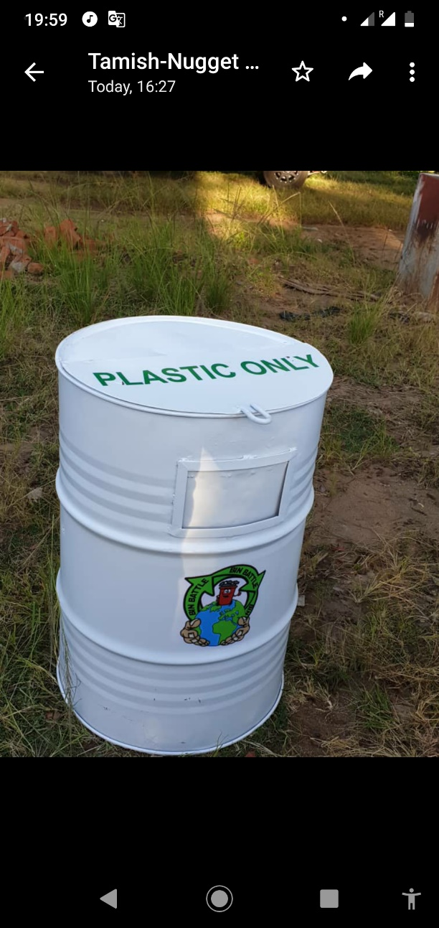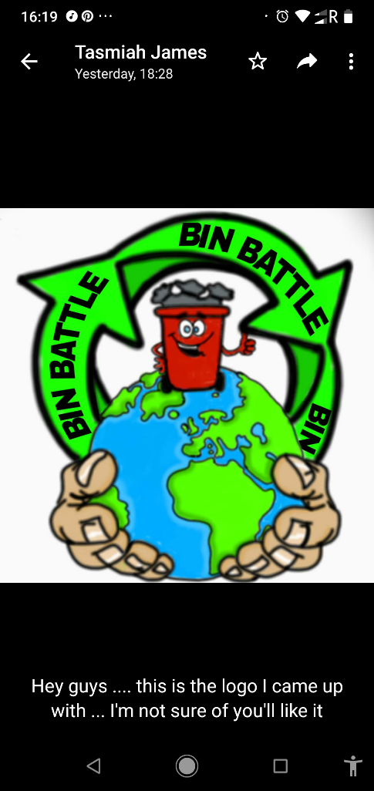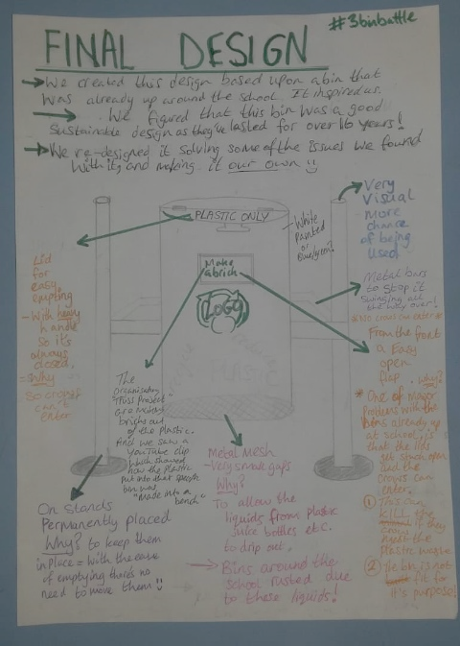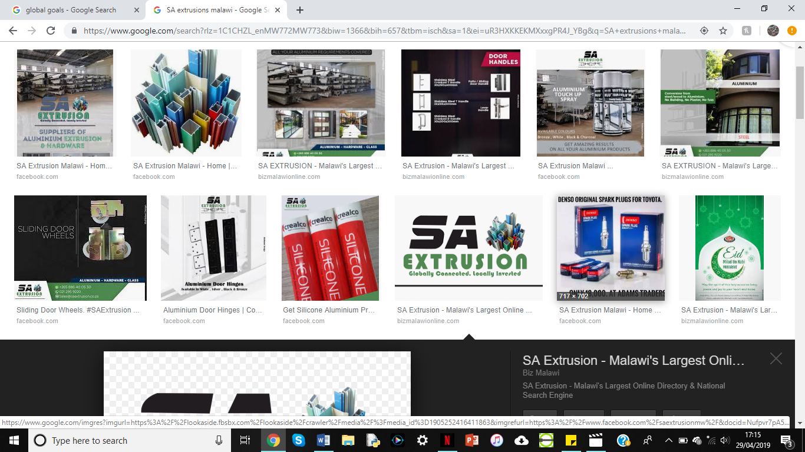 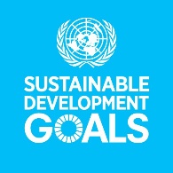

who we’re very proud to be sponsored by and would like to thank for their generosity. We have hopefully inspired our school and SA Extrusions to be more environmentally friendly and make steps towards saving our earth without our input. We would have loved to have made them ourselves but we lacked the talent and also have GCSE’s around the corner but the designs are entirely our own. Also, we delivered an assembly to the entire school to introduce the bins and invited Sachi Shah to raise the profile of the bins. The bins were installed that day and we can’t wait to see their further impact.

**Impact:** We had an impact on our school from the get go. It started off when we created awareness by putting up posters and making badges out of recycled materials. We sold approximately 180, over the course of 2 months, each sold at 200 Malawian Kwacha (equivalent to 20p) so lots of people supported our cause: teachers, staff and students. Also, after the bulletin was being read many people gave us such amazing feedback wanting to help! We also hope that the bins will significantly reduce the plastic on sight and contribute to making Saint Andrews a greener place!

**Feedback:** After our assembly we got so much positive feedback especially from the head of year 8 and 9. She was amazed by all the work we had done and the maturity of our project. She also agrees that it’s such a valid cause and wants us to do another assembly in more detail. Furthermore, the headteacher from one of the local primary schools would like us to help him set up recycling there after hearing about our hard work.

**What we’ve learnt:** One of the most important things we’ve learnt is the power of reality. The response we got to our facts in the daily bulletin was astounding and once they were being consistently read out people were buying badges and asking how they could help. Furthermore, we didn’t realise how dire the plastic situation in Malawi was and how little was being done to help so we’re incredibly proud to being making steps, even small ones, I the right correction. Moreover, we’ve learnt some management skills for a large-scale project which has been tough but we’re so incredibly thankful for the accommodating nature of SA Extrusions and the school maintenance team.

**Future:** In the future we would like to be able to fulfil our original wishes and have bins to separate out all the rubbish produced by our school into plastics, metals, organic and papers and get them all recycled or reused (like organic waste as compost, further used as fertiliser). Another aim of ours is to collect all plastic bottles specifically and donate them to the Tyamike Project which supports women and teaches them to sew, whilst recycling plastic bottles into chairs/ stools.

We would like to thank SA Extrusions again for helping make out ideas and designs a reality!