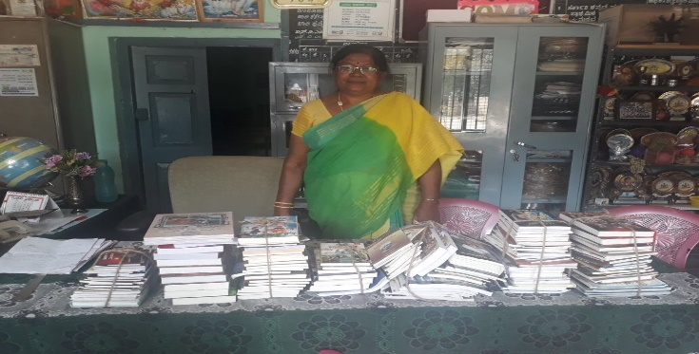
The Triple R Project

Our aim:
- Refresh the environment in the school
- Rebuild the library of the school
- Restore the sanitary and infrastructural facilities of the school
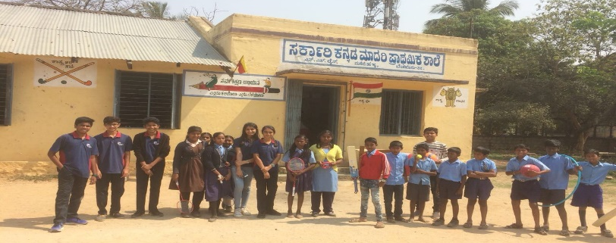

Sarkari Kannada Madari Prathamika Shale, a Government School was asked to shut down and move out from the disputed defence land, leaving the students nowhere else to go. A few years ago, the books from the School's library were burnt and the students were deprived of a library. The School was struggling to cater to the basic needs such as clean drinking water and sanitation. Moreover, the school toilets had broken roof and doors. Our mission was to provide clean drinking water and sanitation facilities besides rebuilding the library.
Funds:
To power our numerous ideas and ambitions for the school we needed funds. To raise money, we
conducted a bake sale at an apartment complex and raised Rs.23,000. This money was spent on repairing the doors of the toilets and making them functional, water purifier, bookshelves and dustbins. To collect the books, we conducted a book donation drive in school and we have donated 700+ books to the library. We installed a RO+UV water purifier that enables them access to clean drinking water at all times. We’ve also installed dustbins to ensure proper disposal of waste. We also instilled in them the concepts of dry and wet waste management. The funds collected were also used to buy sports equipment for an array of sports including but not limited to-cricket, basketball, football, badminton, etc.
Sustainable Development Goals:
- Goal 4 – Quality education
Knowledge is everyone’s birth right and by helping building a library, we have definitely developed reading-learning habit which will empower the students.
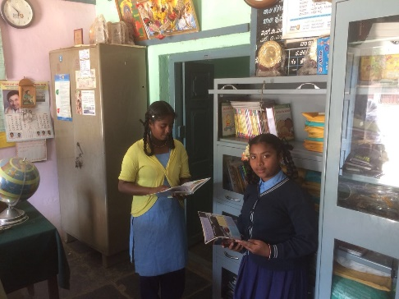
Donation of 700+ books of different genres, languages will feed their curiosity and keep them well informed.
We believe that all kids should have the opportunity to play sports. By providing sports equipment we believe, it will help mould these students into well-rounded individuals.
- Goal 6 – Clean water and Sanitation
We’ve catered to this SDG by providing the school with dustbins and a RO+UV water purifier which enables the students access to clean drinking water at all times. We’ve also educated the students about the importance and need for waste management.
Impact:
We have learnt from first-hand experience, even with limited resources we can make a huge impact in the lives of the under privileged.
We have developed key skills in problem identification, problem solving, fund raising, resource allocation, collaboration and leadership.
It is gratifying to know that through our initiatives we have made a real difference in the overall environment of the school.
-The Triple R Project,
Aarav, Naina, Nishitha, Rishabh, Sagar & Tulsi.
Facebook:https://www.facebook.com/thetriplerproject/?view_public_for=2060416140928960
Instagram:https://www.instagram.com/thetriplerproject/

