Project Name-A better environment for a healthier life.
Project team-Visionaries; Cindy Uwase, Keisha Amri Sued, Divin Lionel(team leader), Aisha Mbabazi, Nina Umutesi, Eva Bigagaza.
Project aim-Improving movement for the war veterans
BACKGROUND
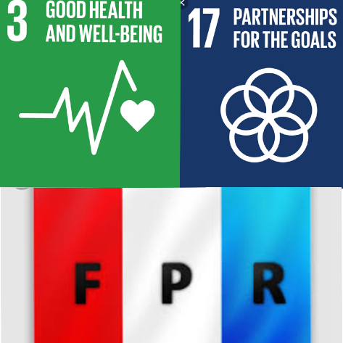
As the youth of Rwanda, we felt as though we should give back to those who risked their life for peace. In Rwanda, organizations
throughout the years have helped many survivors and orphans
from the 1994 Genocide against the Tutsis but we have never
heard the personal stories from the soldier survivors so we
decided to reach out to them.

We reached out to the chief of their village who helped us meet
them. They shared their stories with us and some of them were
teenagers when they joined the army. The Rwandan Patriotic
Front(RPF- flag on the right abbreviated in French) was the army
they joined in the neighboring countries to liberate Rwanda from
bad governance.

Our bumpy journey
After finding the community we wanted to help, we organized a meeting with them and we decided to first know their stories. They all had moving stories and we got to learnt something important. We thought it would be more effective to ask them what they need and so they communicated their need for a better road for both their wheelchairs to last longer and their well-being as they often used to fall from their wheelchairs. We were then taking off on a journey to show our unmeasurable gratitude towards their great work.

The first step was to fund the construction but we had a number of barriers throughout this process. Green Hills Academy has many clubs that needed funding for their upcoming projects and so
the timing was not right for us to organize fundraising events within the school.
That is when we decided to find a new strategy in order not to break our promises.
We first reached out to a few national organizations but they could not invest in anything that is not in their yearly budget. We were now looking for a ‘PLAN C’ and
we were hoping it would be our last. We reached out to anyone who was willing to help, the response was almost magical, and within two weeks, we had the amount we were looking for. On the other side, the chief of their village mobilized the whole village to contribute towards the noble cause.

Once we got the funds, we called upon a road constructor who helped us lay out the road so that it is suitable for the 16 war veterans and their families. On March 16, we invited the whole village, a few students from our grade and our elders to give a helping hand in the conclusion of the construction of the road. We had brought over 100 individuals together and with team spirit, we were passing on the pavements and laying them on the floor.

Our Impact.
A week later, we were back there and David Nzanana could now perfectly move out of his house to enjoy the evening breeze without any help and none of them were home when we arrived. We were very happy to see that they can all go out when they want to. Kayitare Gaetan shared with us his gratitude towards our work, as they are more independent now. We also noticed the kids could play in a freer environment not worried about falling down.

We not only contributed to their well-being we also contributed to the infrastructure of the country and to achieve this we collaborated with the village’s authorities to achieve our goal.

We believe that the surroundings may have an influence on one’s mental health. As soldiers survivors, we believe that a bad environment may not only deteriorate their mental health but it is also physically straining.

We were also able to encourage the youth to make a difference despite their age.
The response to the noble cause was very encouraging. We are more than
privileged to be living in a peaceful and developing country so it is the least we
could to show our gratitude.

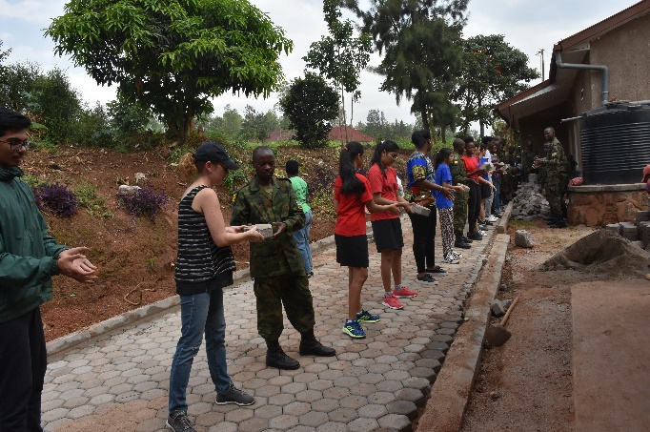
How GSL has impacted us.

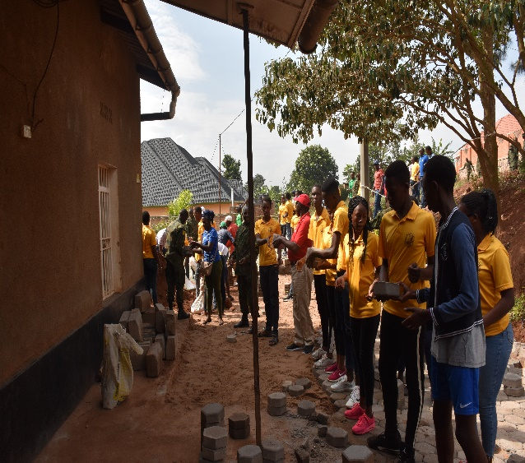
Through GSL we have been able to impact a community that we hold at heart. Our conversations were very interactive and their stories lightened up our views on the history of our country. At a time, where ethnicity was significant Karangwa had to flee to Uganda to protect himself. He was a fit young man at the time and he wanted to join the army. He joined the army in Uganda that his fellow rwandans were in and he was determined to return home along with the rest. Refusing to stay refugees the attack was planned and Karangwa as captain was leading the group to free Rwanda from bad governance. He was shot twice in 1991 during the liberation war.

Another soldier now very injured who was forced to join the army at a very young age because the discriminated ethnic group was not allowed to go to school. He was only 16 when he joined the RPF. He was able to save some people before he got injured.

Through their stories we were able to become inquirers. This project taught us resilience and determination. After the numerous fails with our fundraising methods we learnt that giving up was not a choice especially for a community we hold at heart. With all the time spent on this project we knew that hardwork is key and that it takes up a lot of courage to be able to bring more than 100 people and leaders together to help towards the cause.

It was a pleasure to hear the life lessons they had to tell us and their wise words are going to walk with us forever. In the future we will be more flexible in the way we organize events because we know how to.

GSL has made us great young leaders. We are now communicative, inquirers, organized, resilient, open-minded, curious and we have learnt so much from our elders.

With this project we were able to help people who needed it and involve people like the Mayor of our district. We now have expanded our public speaking skills and writing skills. Our project was sustainable because we used clay and water to lay the ground and make it flatter than it was. The main road was tarmac and even though making tarmac is not environmentally-friendly and it is meant for the long term and does not need to be retouched.

Our Future plans

It has been a great journey to success. We made it to the New Times and we want to continue being the rainbow in the needy’s clouds. The school was also very proud of us for the work done.

We would like to reach out to even other needy community and continue the legacy. It is nice to see people happy and grateful for the little you could give them.

In conclusion, GSL has been a great experience for all of us. We are thanking all the people who helped in one way or another and especially to GSL.

