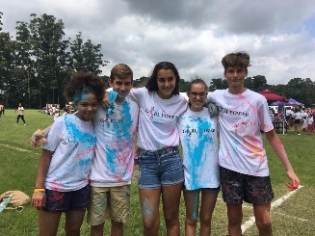
GLOBAL GOALS -Sanitation vacation
Breaking the Taboo – Period!

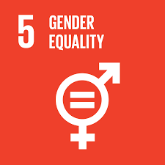
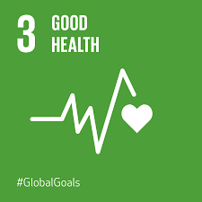
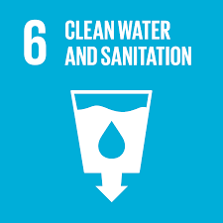
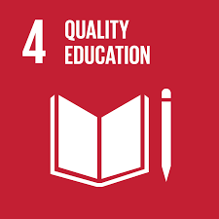
Malawi is a located in southern Africa and one of the poorest countries in the world. The country faces significant challenges in achieving the 17 Global Goals as a whole, but as a group we wanted to look at challenges which face children of our age. We appreciate that we are very privileged in Malawi to attend an excellent international school. But just next door to our school is one of the poorest areas of Blantyre and we felt we should take time to understand the challenges our counterparts face and how we could help. Following some research, we found that many girls do not complete secondary school in Malawi, and one of the main reasons for this is that they miss school when they are menstruating, fall behind and then drop out. Managing menstruation therefore has an impact on four Global Goals!
Our aim was to support girls to manage their periods so that they do not miss school. To be able to do this we decided to do the following activities:
OUR TEAM ROLES
- Momcilo Randjelovic- presenter, email organizer (writing this) and logo designer
- Garrett Bertrand- knowledge of locals, cultural understanding(culture kid),presenter
- Tadala Mfutso-bengo- language translator, barnstormer, presenter, fundraiser Ideas.
- Acacia Morse-Fundraiser organizer, arts and crafts person and has contacts with pad supplier, presenter
- Nazra Hawash-Social media designer, fundraiser ideas, presenter
- Talk to experts in menstrual hygiene management in Malawi for advice
- Visit a local school and talk to the boys and girls to understand the issues from their side
- Talk to the girls we could support about that they wanted
- Raise money and help the girls as best we could
- Educate our fellow students at Saint Andrews International High school about the challenges girls face with menstruation
To understand the issue more fully, we visited Ndirande Hill School on the 11th of March, where the boys talked to the boys (10) and the girls talked to the girls (20)! We learned a great deal from our visit including the taboos around periods and taught them about some of the correct issues as well. Funnily the boys knew more about periods biologically than the girls.
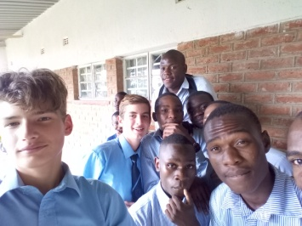
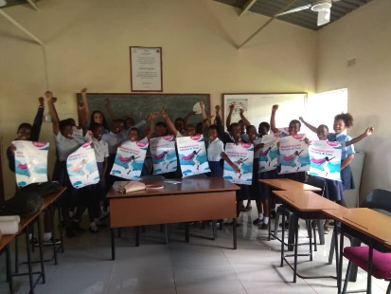
Most girls said they cannot afford pads when they have their period and so they use leaves and rags/cloths, and miss school. We showed girls the different pads available in Malawi and asked what they would prefer.
We can only speak to our mothers and sisters about periods and boys tease us. There are also traditions where girls have to sleep with a man then they get their first period – said by girls
When a girl goes to buy pads for their periods the boys know they are ‘ripe’ and want to sleep with them to make them pregnant – said by boys
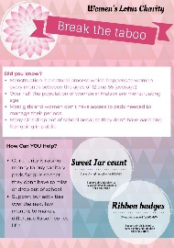
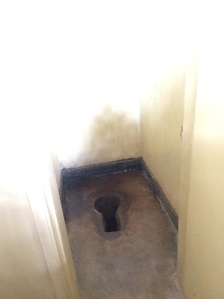
They did not like disposable pads as some were worried about people using them for witchcraft against them so they preferred the washable ones. We did research to make sure we found the best washable pads, which would last the longest, be easy to wash and dry quickly. We found AfriPads were the best and they were also really helpful and offered to come to train the girls about menstruation and how to use and look after the pads. We also visited the school facilities and they showed us how they had no water for washing at the toilets and the toilets had no locks so they had no privacy when they went to the toilet as well.
So with our new understanding and enthusiasm we set out to raise money. Each set of pads would cost would cost five pounds and we wanted to support 100 girls with pads and also purchase and donate equipment that supports the usage of pads such as locks for privacy in bathrooms and water tanks for washing.
We began fundraising with bake sales, jar counts and sales of Acacias amazing handmade ribbons. We also wrote some charities in the UK for support. We raised 54 pounds from our efforts at school, and 500 pounds from the Monymusk Charity in the UK to support our cause.
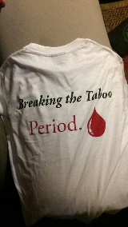
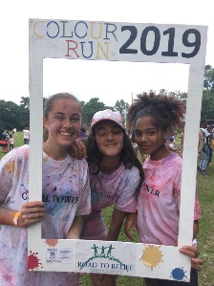
But raising money was not enough, we also wanted to raise awareness. We had Lucy Nkhoma from ActionAid Malawi come and talk to our fellow Year 10 students – they had a lot of misconceptions! We had great fun putting up posters in school to #break the taboo and we ran a fun run wearing shirts advertising girl power and our strides to help periods, sadly Garrett couldn’t bear wearing the shirt for than five minutes.

Outcomes
AfriPads also came to Ndirande Hill School when we handed over the pads and trained the girls on menstruation and also on how to look after their pads.
Thanks to the Scottish funding 100 packs of Afri-pads were purchased and given to the girls at Ndirande hill. In each pack came three pads with different flow levels and size. The girls were very grateful as these would reduce the financial burdens they faced. The group is regularly staying in touch to see the effectiveness of the Afri-pads. As girls have been motivated and advised to speak to each other about problems they face, possibly in long term the “breaking of the taboo” will be seen.
The bathrooms can be locked, ensuring privacy and taps with small buckets to catch remnant water had been emplaced to ensure hygiene and sanitation.
The project has had positive economic, environmental and social outcomes, with the project being a success and effective. These 100 girls will now be able to attend school without worrying about finding pads to use the next day.
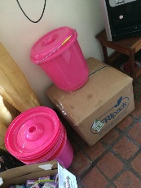
What we got:
- 100 pads
- 100 bars of soap
- 5 buckets with taps
- 5 smaller buckets
- Locks for the bathroom doors

