Name of the School and Address - Abu Dhabi Indian School, Branch 1, Al Wathba .
Baniyas East , Abu Dhabi, United Arab Emirates
INTRODUCTION
(i) Purpose | The role of electricity in today’s world is inevitable. Different type of sectors makes use of electrical energy in various ways. The latter is obtained from nonrenewable sources such as petroleum ( Digboi, Kalol) and coal( Jharia, Korba), etc. Being residents of the United Arab Emirates and also the global citizens, we have understood the need of renewable sources from where electricity can be obtained. Thus, our “BICYCLE TO RECYCLE” project is one such innovation that can be used as an alternative for the electricity production along with other benefits. The intention of this project is to build a straight forward human powered generator from a used bicycle and to use it to power light bulbs, blenders, cell phones, laptops, and other small appliances. This project will help one develop engineering skills while learning about a clean way of generating electricity.
(ii) Scientific Principle Involved | Conversion of mechanical to electrical energy is the basis of our innovation. The use of an inverter also produces AC current from DC current.
DESCRIPTION
(i) Material/s used | - Bicycle  - Wood  - Screws,nails,Hammer and Wood Cutters  - Diode  - Battery

- Inverter
- Dynamo with permanent magnet inside (12v or higher)
(ii) Construction and Working | - We collected used bicycles, batteries from Garage, dynamo and electrical wiring materials from car garages and scrap yards .Other materials from friends, family and neighborhood.  - Next Step was to clean and treat the bicycle with rust proof primers and paint.  - We built a stand made of wood to elevate the bicycle off the ground for the easy rotation, while being in fixed position.  - The Dynamo is then attached to the cycle. The dynamo and belt should spin concurrently without slipping.  - We placed a diode in series with the battery and the motor. Simultaneously, we made sure that the current flows only from motor to the battery.  - Next,The negative terminal of the battery should be connected to negative lead of the dynamo and the positive lead from the dynamo should be attached to the diode and the diode to the positive terminal of the battery.  - Next we connected the battery lead to the inverter, by passed through a switch, which converts DC Current stored in the battery into AC Current, which can be used for all the home appliances which uses 240V AC.  - Inverter outlets were connected with an extension cable with 240V sockets for the easy distribution of power.  - Direct Battery out was bypassed with switches and connected with few converters which converts 12V DC coming from the Battery into 5V DC USB port Power for charging Mobile phones and tablets.  - Extra 12V terminals were fixed to drain 12V direct power from the Bicycle system to use it for Corridor Lighting project and LED lighting systems for the Hydroponic system as well as entertainment system which run with 12V power.  Working :

During the pedaling of the bicycle, its generator is spun by the movement of the bicycle’s wheel. The generator is made of a spinning magnet within a coil of wire, as the magnet spins, electricity flows through the coil
( Electromagnetic Induction). Thus, mechanical energy is converted to electrical energy. The energy you generate can be used straight away or can be stored in a battery in the power pack for use later. The 12volt DC current is converted to 240 volt AC current in the inverter as mentioned above in the construction section.
(iii) Application (if applicable) | - Application of AC current :  - Classroom lighting - CFL and LED Panels which uses 240V AC  - Refrigerators , Televisions,PA Systems and laptops.  - Applications of DC Current:  - Charging phones, and other handy gadgets using 12V to 5V converters.  - Entertaining systems such as music players.  - Corridor LED Lighting.  In our school:
- To provide electrical energy for the corridor lighting project.
- To pump the water and to light the hydroponics developed by the students.
- Lighting the classrooms from the electricity obtained from the bicycle generator.
- Special Media player / PA system uses this electrical energy to get charged. ( Prepared by the students)
How does our project meet the global goals?
- To reduce poverty: By providing social protection, equally accessible as it uses innovative technology. It also gives access to electricity. Over 1.2 billion people - one in five people of the world’s population - do not have access to electricity. The majority are concentrated in about a dozen countries in Africa and Asia.

- Good health and well being: It acts as a good muscle workout, good for strength and stamina and is also a fun and time-efficient way to get fit. Thus, it prevents obesity, cardiovascular diseases,
diabetes and mental illness.

- Affordable clean energy: Our project focus on clean energy that is affordable, reliable and sustainable for all the people. Thus by adopting the project we also reduces the use of fossil fuel which is of a large concern in today’s world.

- Industry,innovation,infrastructure: We would like to install our project near vending machines so that in the pursuit of buying snacks, children would be encouraged to pedal our bicycle generator. In situations of natural disasters ( or no electricity), these cycles would produce electricity. Moreover, our cycle is mobile which is indeed innovation.

- Sustainable cities and communities: To make cities inclusive, safe, resilient and sustainable we need to increase the use of renewable energy.
ILLUSTRATIONS
(i) Black and white line and labeled diagram of the model. Illustrate the working of the exhibit/ model | 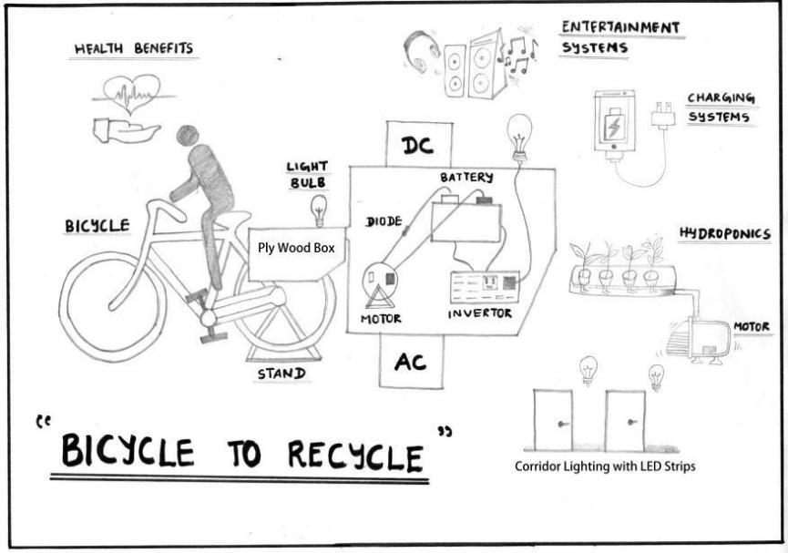
(ii) Close – up photograph of exhibit/model | 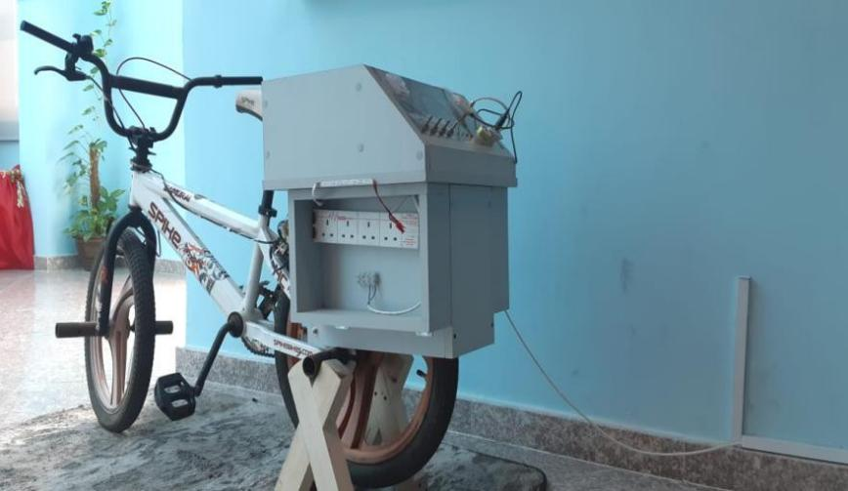
References (if any) | https://www.globalgoals.org/

