Hope for you

Aims
- Visiting and interacting with the children at the Fundeni Clinical Institution to relieve suffering induced by the treatment for their terminal diseases, such as cancer.
- To raise funds for the Speranta pentru tine association in order to fund treatment costs.
- To raise awareness and inspire involvement towards helping our cause.
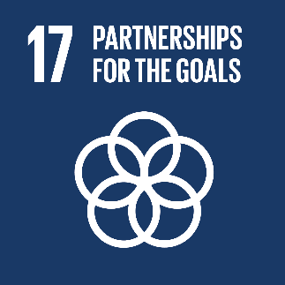

Our sustainable goals

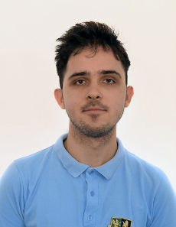
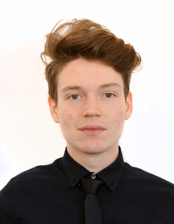
  - Our members:
Andrei Vagaon – donation fund master
Stefan Anghel – professional pastry baker
Alex Ciolan – stand-up comedian & historian
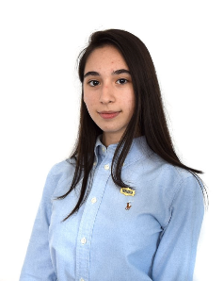
Matei Constantinescu – conversationalist
Luiza Ruptureanu – presentation enthusiast
Ms Blessy Savu – team parent

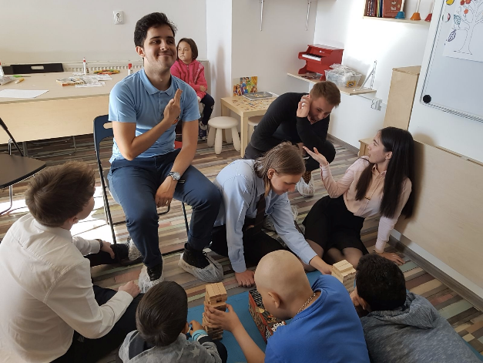
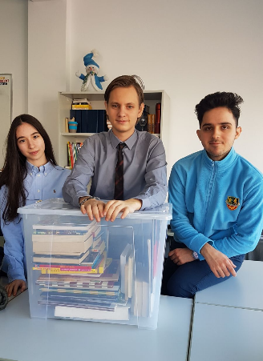
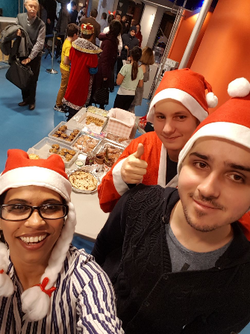
Across the 10 visits to the playroom we have carried out this year, we’ve all learned to work together to organise activities with the children, but also discover ways to put in effort towards coming up with new activities that can attract relations with other people and interest in our charity group.

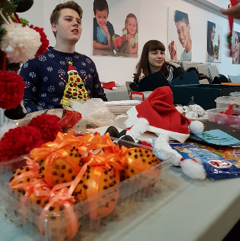
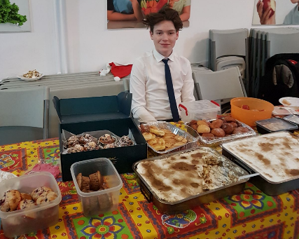
We baked…

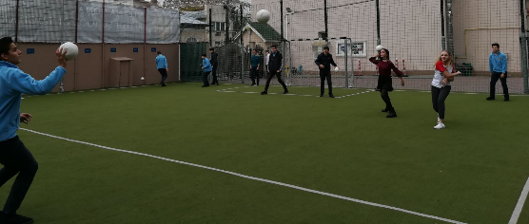
We played dodgeball…

We face-painted…
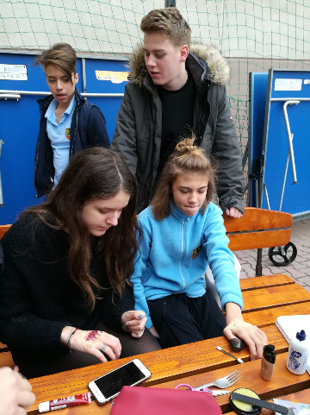

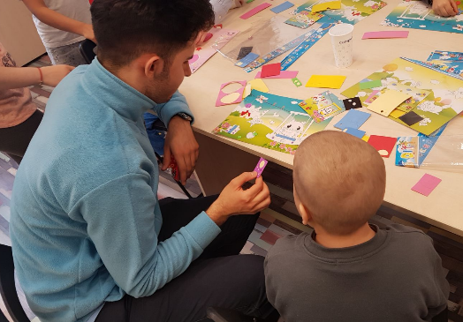
We bonded…
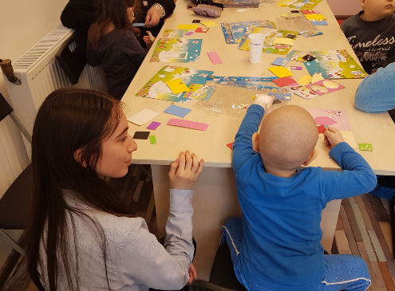
We planned, presented, called friends in to contribute, and raised money.

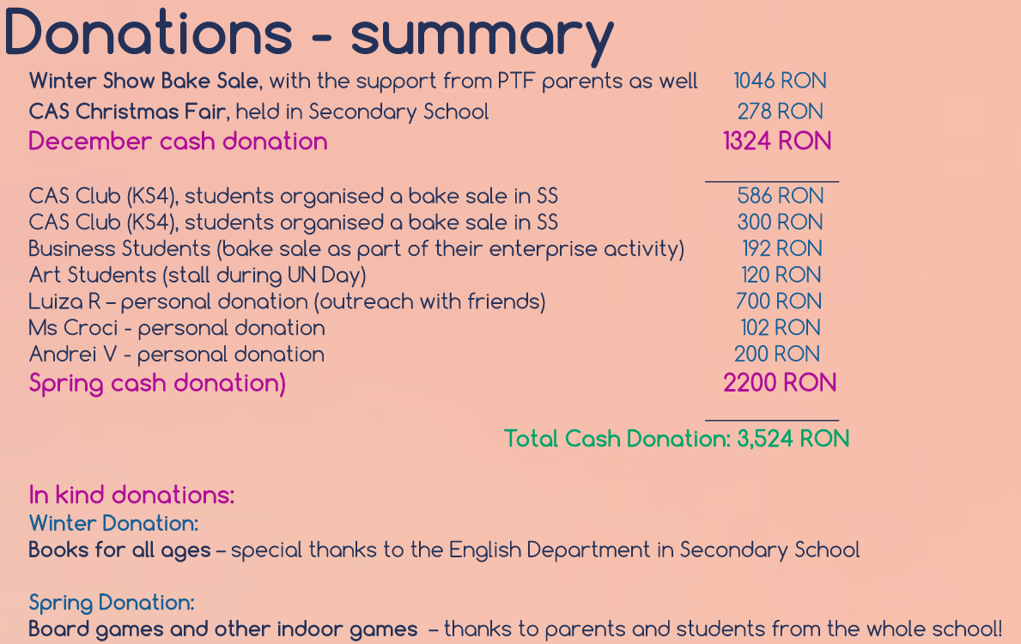

“We had our successes and failures, but we walked away with long-lasting memories, knowing that our efforts brought happiness”

